UK expertise to support high quality statistics for the global public good

Business Case

ONS Accountability Framework Objectives (AFOs)

To deliver the critical targets in the International Development Strategy, in particular:

- meet agreed results targets and communicate results transparently (publishing to the cross HMG development tracker)
- increase the number of strategic country partnerships during the SR period and to 7 by March 2023
- ensure the ODA budget is spent only on ODA eligible work and conforms to IATI standards

Table of Contents
0. Executive Summary 3
0.1.1. Project Summary 3
1. Budget 3
2. Stakeholder engagement 3
3. Strategic Case 4
3.1 Vision and alignment with ONS objectives 4
3.2 Benefits 4
3.3 Theory of Change 5
3.4 Risks ..……………………………………………………………………………………………………………………………………………….8
3.5 Equalities Assessment 9
3.6 Climate and Environment Assessment 9
4. Economic Case 10
4.1 Critical Success Factors 10
4.2 Options Considered 10
4.3 Preferred Option 13
5. Commercial Case 15
5.1 Contracting Implications 15
5.2 Personnel Issues 16
6. Financial Case 16
6.1 Cost 16
6.2 Efficiencies 17
6.3 Affordability and Funding Arrangements 17
7. Management Case 17
7.1 Project Management Arrangements 17
7.1.1. Reporting arrangements 18
7.1.2. Governance arrangements 19
7.1.3. Key roles and responsibilities 19
7.2 Benefit Realisation Arrangements 20
Risk Management Arrangements 20
7.3 Monitoring and Evaluation 21

Annexes
A. References
B. Delivery Plan
C. Risk Matrix

0. Executive Summary
The Office for National Statistics (ONS) international development programme works to strengthen statistics for the public good in developing countries. This project will enhance our international development work, through the delivery of technical assistance during the period 2022-2025. We will build on the impact delivered in the previous phases (2017-2022), consolidating progress in existing partner countries, and adding additional priority countries and new technical areas.

Project Summary
The primary aim is to support statistical modernisation and capacity building in developing countries. The project will deliver on the goals set out in the international development strategic plan Statistics for the global good – High-quality statistics to improve lives globally – UK Statistics Authority. The ONS international development programme has been successfully delivering results since 2017.

Budget
The budget for the project is £12.6 million, of which 3.6 million for 2022/23, £4.2 million for 2023/24, and £4.8 million for 2024/25. This will allow us to steadily increase our reach to new countries and to explore opportunities to expand our impact into new topic areas (prioritising health, and climate and environment). The money will be spent in accordance with aid spending requirements.

Stakeholder engagement
Key external stakeholders will be National Statistical Offices (NSOs) that will be directly impacted by the project; The Foreign Commonwealth and Development Office (FCDO), centrally and at a country level, with whom we have excellent links, to ensure that our work reflects the wider priorities of His Majesty’s Government (HMG); and other organisations that work on statistical capacity building, with whom we engage regularly, to avoid duplication and offer value for money and effective outcomes.
Key internal stakeholders will be experts from across the ONS who will support the work with their expertise; senior leaders from across the ONS, who will champion our work at the highest level; the ONS international relations team, who will ensure this work is part of the overall ONS/Government Statistical Service (GSS) approach to international engagement; and ONS enabling functions that will adapt ONS systems to ensure effective international working.

Strategic Case

3.1 Vision and alignment with ONS objectives
Our overall vision is “high quality statistics to improve lives globally”.
The project will deliver on the majority of the goals set out in the international development strategy Statistics for the global good – High-quality statistics to improve lives globally. It is part of the commitments in the UKSA Statistics for the Public Good Strategy 2020-2025, underpinned by the GSS International Strategy, Statistics for the Global Good. It is aligned to the UK Statistics Authority’s strategy principles by being radical, ambitious, inclusive, and sustainable.
by being:
- Radical in the expansion of subjects covered and scope of advice, compared to previous stages of the work. It aims to support developing countries to share in the innovation within the ONS, to continue to prepare statistical systems for the future.
- Ambitious in our reach and impact across the developing world working adaptively to prioritise and respond to changing and complex environments.
- Inclusive in our engagement with partners and their stakeholders in the development and implementation of their work. We will also seek opportunities to promote inclusivity of data as part of collection, analyses and dissemination.
- Sustainable in the relationships and partnerships we build, prioritising activities that will deliver meaningful impact and long-term change.

3.2 Benefits
The main benefits associated with the achievement of the project’s spending objectives are:
- The improved trustworthiness, quality, and value of statistics in developing countries, and
- Increased institutional performance, profile, and legitimacy of key partners.
This will in turn lead to more evidence-based decisions and policy making in partner countries and globally, ultimately supporting our vision of high-quality statistics to improve people's lives globally.
Benefits will be measured using indicators that align with the aims of the project at output, intermediate and long-term outcome levels (see section 3.3). Targets will be set annually against these and monitored to confirm the benefits from the project’s initial activities to longer term impact. The project’s results framework is designed to demonstrate benefits at both partnership and at overall project level.
The main interdependencies that would impact upon the delivery of these benefits are:
- Assumptions in the theory of change around absorptive capacity in partner organisations
- Dependencies within the ONS on expertise, technology, and leadership
- Dependencies on wider HMG to ensure our work aligns to wider UK goals and expertise

3.3 Theory of Change
The Theory of Change is shown in Figure 1. This was developed in consultation with stakeholders and will be regularly reviewed in collaboration with them to ensure its continued accuracy and relevance. The programme’s logic is based on evidence of the impact of statistical capacity strengthening from across the international statistical system.
The project’s outputs include increasing individual and organisation-wide skills and knowledge, for example, in statistical methods and data science; supporting good management to ensure these skills are implemented; and providing the mechanisms necessary to support the sustainability of this work at a system level through resources such as legislation, a National Strategy for the Development of Statistics (NSDS) and improving relationships with stakeholders. The outputs and activities will not look the same in every country, and it is essential to identify ONS comparative advantage and coordinate with other development partners on the ground, to avoid duplication.
The intermediate and long-term outcome levels show the direct changes that we expect to occur because of the outputs being achieved. These relate to improved trustworthiness, quality and value of statistics in developing countries, as well as improved institutional performance, profile and legitimacy of key partners. Although we cannot always fully attribute achieving these outcomes to our work, it is important to evidence the role that our programme played (or what may have limited it) to learn what works and why and how we can improve our logic and delivery. Development partner coordination is essential here too, to maximise progress towards the partners goals.
The impacts and vision show the long-term change that our work should contribute to bringing about. Our goal is to improve the quantity and availability of good-quality data both in our partner countries and for global development initiatives, leading to more evidence-based decision-making and policy making, ultimately improving people’s lives globally through the power of data and statistics.
As we work in complex environments, it is vital to understand the assumptions that need to hold true for the links between stages of the desired change to be realised. A key overall assumption is that, while we directly create change at the individual and organisational level, the subsequent effects will lead to changes at system-level, and this will be the incentive for our partners to maintain our partnerships. Other assumptions include that partners’ skills and knowledge gained will be successfully applied to improve official statistics, and availability of adequate resources. Monitoring assumptions will allow us to understand how the logic is, or is not, translating into delivery.
Where we have medium term peer to peer partnerships, and especially where we have a presence in country, we are more able to monitor assumptions, and we have more of a sight to the higher level results in the theory of change, which can allow us to identify opportunities and blockers and bring in others, including the wider UK government team, to increase progress.
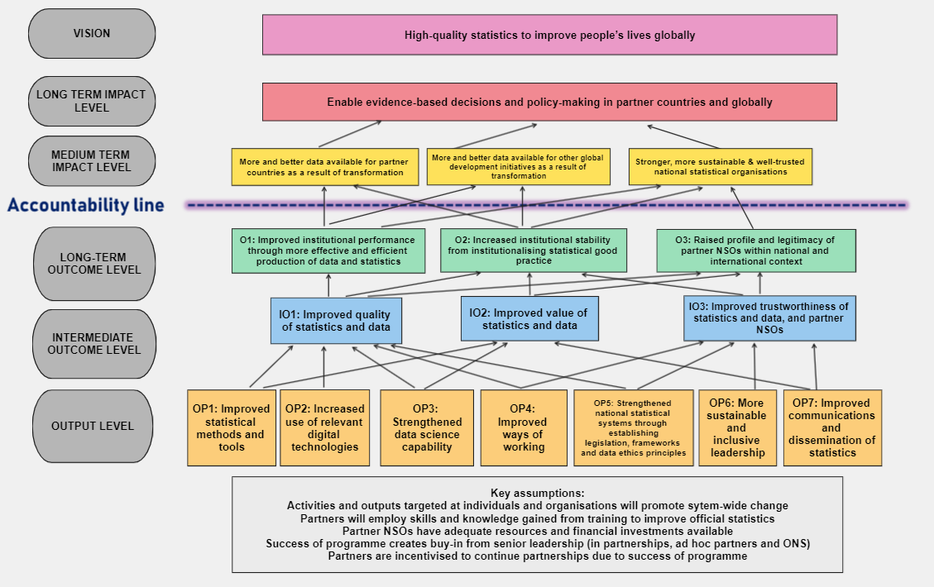
Figure 1: ONS International Development: Theory of Change diagram

3.4 Risks
The level of risk in previous years has been classified as minor by the FCDO, in comparison to other UK ODA-funded projects. The appetite for risk and approach varies by type. Tighter mitigation measures are applied in areas where the appetite is lower. In some cases, if the risk were to materialise, it could lead to termination of part of the programme.

Risks include:

- Delivery: Programme only delivers technical assistance. It does not provide direct funding and cannot cover core costs which the government incur in collecting, analysing and disseminating statistics. Risk is mitigated by ensuring that topics supported by ONS are high priority for the NSO and are sufficiently resourced. Critically, in-country staff form strong relationships with the partners’ senior leaders, which enables them to understand the context, priorities, and absorptive capacity, and ensure the activities are designed and delivered appropriately.
- Operational: Security, health and safety and safeguarding risks are mitigated carefully through close working with FCDO and OneHMG initiatives to align our policies. We ensure staff are well briefed on health, safety, security and safeguarding risks, and their personal role in mitigating them.
- Reputational: Partnerships bring a risk that the ONS and/or UK Government could be associated with (real or perceived) problems within partner countries or organisations. We work closely with the ONS communications team and FCDO to monitor and mitigate risks, considering the specific context with each country. Our programme focusses on technical areas and remains politically neutral. We encourage and advise partners to avoid potential problems within their organisations, for example, by having appropriate legal and policy environments, a suitable code of practice, and effective communications.
- Fiduciary: Risks of fraud and corruption between the ONS and partner NSOs are very low: the programme is designed so that the ONS manages all procurements and does not provide funding to partners.

3.5 Equalities Assessment
This project relies on ONS experts. It provides those experts with opportunities to learn from and engage with other NSOs, building their own skills along the way. We aim to be inclusive in everything we do, consistent with the ONS inclusion and diversity strategy, and to ensure that the technical assistance we provide is reflective of the societies we serve. To achieve this, we aim to attract, retain and nurture talented and skilled people from diverse backgrounds. The IDT will continually assess whether their own approaches, and wider ONS policy facilitates equal access to opportunities.

Good quality disaggregated statistical data has the potential to improve equalities and ensure that no one is left behind. This programme will contribute to reducing inequalities in partner countries by:
- Providing technical expertise to the Inclusive Data Charter (IDC) secretariat and supporting IDC champions in the development and implementation of action plans, to enable them to act on inclusive data
- Developing the quality and quantity of inclusive data. For example, supporting UNECA in their role in gender data across the continent, working with countries to better capture informal employment (often carried out by more excluded population groups), ensuring that censuses capture excluded groups, disaggregated census outputs are produced, and new forms of data to improve geographic disaggregation of indicators are used
- Striving to improve inclusion in the organisations we work with, by role modelling an inclusive workplace; by ensuring our training and mentoring opportunities are open to a range of people; and by rolling out a ‘Women into Leadership’ programme.

3.6 Climate and Environment Assessment
The UK Government has committed to ensuring that all new bilateral UK ODA aligns with the UN’s Paris Agreement 2023. This project is consistent with that agreement.
As the provision of technical assistance is unlikely to be subject to climate or environmental risks, a Climate and Environment Risk Assessment is not required at this stage. The only major carbon expected to be emitted is that associated with international travel. Given that some international travel is unavoidable to achieve the project’s impact, completing a Shadow Carbon Pricing is unlikely to be informative for the project. However, the project will take environmental impacts into account when making decisions to travel, and support and implement the wider ONS policy for reducing the carbon footprint of the organisation.
There will be opportunities for the project to impact fossil fuel policies and partner countries’ own climate plans. Robust and accessible statistics equip policymakers and stakeholders to make decisions and inform more effective responses to climate change. The ONS is developing its expertise in climate and environment statistics in many ways and the project will seek opportunities to provide support to partner countries in these areas, where feasible and needed.

Economic Case

4.1 Critical Success Factors
This project will be considered a success if:
- It meets agreed results targets and communicates results transparently (publishing on the cross-HMG development tracker within four months of end of year)
- It increases the number of strategic country partnerships to seven during the Spending Review period by March 2023
- The ODA budget is spent only on ODA eligible work and conforms to IATI standards
- The project offers good use of resources, based on feedback from key stakeholders (see section 3) gathered during annual reviews and end of project reviews.

4.2 Options Considered
The UK Statistics Authority has been allocated this resource through the spending review for the purpose of supporting statistical capability strengthening. Therefore, this options appraisal is limited to the ways which this project could be delivered and the decision-making process that has been followed.

Option No. | Description | Advantages | Disadvantages | Decision
Do nothing | No specific ODA funded international development programme in the ONS. The ONS continues to provide light touch / ad hoc support to all countries around the world through our international relations team. | Light touch and easy to manage within existing resources. | Reputational impact as we cancel / scale back existing partnerships. Limited future scope to provide transformational change in developing countries. Limited scope to follow up on ad hoc support and learn wider lessons. Limited scope to systematically and proactively pass on some of the lessons the UK has learned on its modernisation journey. | Reject this option.  Evidence from previous reviews shows this work is in demand and is achieving results and offering value for money.
Delivery Framework
Peer-to-peer partnerships only | In-depth engagement, via peer-to-peer partnerships, in a few selected partner countries. | Significant scope to influence change in a few, well-selected countries, based on evidence gained from our pilot phase.  Contextual understanding from an enduring partnership, often via embedded strategic advisors can make the ONS offering strong and impactful. | Limited reach to specific countries – not making the most of ONS leadership in particular areas to impact globally. Limited ability to respond flexibly when new demands arise. | A significant part of our investment will go into peer-to-peer partnerships. We will maximise the benefits of lessons learned from this.
Global programmes only | Broad engagement reaching as many countries as possible with well-developed products and services, for example specific training courses/data science mentoring. | The ONS can systematically and proactively pass on some of the lessons it has learned on its modernisation journey. Contact with more NSOs. Opportunities to raise our profile as an expert in particular areas at international forums. | Limited understanding of the local context to tailor our advice or ensure it is impactful and sustainable. Reduced closeness in relationships with potentially less trust gained which could reduce impact and sustainability. More similarity with other international programmes, reducing our USP. | A smaller but important part of our investment will be for global programmes.
Hybrid option | Balanced combination of the above options, drawing on the strengths of each. Making the most of regional synergies and linkages, and trilateral working. In depth, bilateral relationship in some key countries.  Where we have proved the success and demand of a set of activities – the project will invest in ring-fenced resources within the ONS, enabling us to deploy these to new countries/organisations. | Bilateral partnerships allow us to make a sustainable impact in some key partner countries.  Broader reach allows us to systematically pass on and share lessons in areas where the ONS is a global leader. | More complex to manage and report. | Selected  This option will enable us to maximise impact.
Scope of work
Flexible statistical capacity strengthening | Flexible engagement including wide use of sub-contracting and use of experts from the global south to meet partner needs alongside ONS staff. | Allows our partners to have access to a wide range of different sources of technical assistance, building lasting capacity. Increased ability to respond flexibly when new demands arise. Use of local experts increases diversity of talent being supported through programme. | Doesn’t play to the ONS’s strengths. More similarity with other international programmes, reducing our USP. Reduced scope to bring any lessons back to the ONS. Requires new capacities, for example in local contracting. Increased fiduciary risk and potentially delivery risk, by introducing additional delivery agents. | We will take on lessons from best practice and gradually expand the different types of assistance that we are able to provide. But this will be small as a proportion of overall activities.
Focus on ONS expertise | Focus partnerships only on areas where the ONS is strong, ensuring minimal use of contractors. | The ONS can systematically and proactively pass on some of the lessons it has learnt on its modernisation journey, playing to its own strengths. | Limited flexibility in the scope of our activities, due to greater reliance on ONS experts. Less flexibility in the timing expertise is available as work would have to fit around ONS deadlines. Risk of lower level of understanding of the organisations we are working with. | This will be the large part of our programme and drive our ways of working.
Hybrid option | Focus largely on areas where the ONS is strong, in line with overall theory of change, complementing ONS experts with external (and especially more local) expertise where that assists in delivery of joint objectives | Plays on the ONS’s comparative advantage but will enable us to remove some blockers and/or get better value for money in some parts of the project. | Will require some new capacities in the ONS. | Selected

4.3 Preferred Option
Based on lessons learned during the pilot phase of our programme and advice from ‘the PMOS review’ our overall delivery framework for international development takes the form of key partnerships, and some core technical areas for which we have ring-fenced expertise available.
Evidence from other projects aimed at capacity strengthening, including that from a synergy of evaluations of statistical capacity building programmes shows that both country ownership and alignment, or local relevance are key in building sustainable capacity. Our partnerships

will always flex to the local context. However, the ONS’s comparative advantage comes in sharing our own experience and expertise, and as we look to ring-fence skills and expertise for our international development work, we will seek opportunities to deploy these resources effectively.
Peer-to-peer partnerships
The project will deliver its goals via enduring, structured peer-to-peer partnerships driven by the partners’ modernisation plans and needs. Evidence from annual reviews shows that ONS expertise is highly regarded, but it is the contextual understanding from an enduring partnership, often via embedded strategic advisors, that makes the ONS offering strong and impactful.
For each partnership we will review the model needed based on the scale of the project, contextual factors, and value for money and plan for appropriate exit strategies.
Through these partnerships, we have supported many aspects of statistical modernisation, case studies of which can be found on our website. All partnerships involve a wide range of technical experts from across the UK statistical system, working with their peers in areas of mutual interest. During this period this will include experts in:
- Data science
- Training and development
- Census design and management
- Methodology
- Communications, stakeholder engagement, dissemination and output design
- Prices
- Labour market data
- Data linkage, data protection, and data acquisition
- Governance, stewardship and codes of practice

Core technical areas
While we will work with partners on a range of areas aligned to their needs, we will seek opportunities to draw from a list of core areas where we have developed our expertise and, in some cases have ring-fenced resources. These will be closely linked to areas which are fundamental to statistical transformation. We may also include other non-core areas in our partnerships, but we recognise that the ‘offer’ will be less refined and may be harder to deliver. Where we have built a strong, in-demand offering in a particular area we will seek to use our connections with others to increase its reach to further countries and organisations. A key example of this is our global leadership in strengthening data science skills. In previous reviews this has been cited as providing “valued, specialist support in a highly technical, in demand, area”.

Use of sub-contractors
We recognise the wealth of expertise that already exists in the developing world and how impactful South-South cooperation can be. We have the scope to look to other avenues to complement ONS expertise, where required. The external review of the previous project recommended “considering use of local consultants as an alternative to UK-based technical assistance, where they are cheaper and can add value, e.g., through understanding of the local political context; but only where quality can be assured, and with strong ONS oversight”.
We have used our programme in some cases to subcontract local experts (see commercial case) and will continue to explore this route, however it is not to our comparative advantage and has required significant overheads in terms of ONS procurement inputs, so we will only do so in occasional and justified cases.
South-to-South partnerships
In addition, we will use this project to bring our partners together for mutual learning where possible. Our previous phases have shown that trilateral work and discussions (for example, the ONS, United Nations Economic Commission for Africa and one or more African statistics office) can be extremely impactful.

Commercial Case
Most of this work will be delivered by ONS staff, sharing ONS experience in statistical modernisation. Some minor elements may be contracted out or delegated to other organisations, when in line with overall objectives, and when value for money can be assured.

Contracting Implications
Sub-contracting may be required in some situations, for example if:
- A local contractor can work with ONS staff on a piece of work at lower cost or greater efficiency than ONS staff, or to help overcome short term risks or challenges.
- Expertise is required in areas where the ONS does not have the niche skill or the spare capacity, to unblock issues and take forwards the partnership’s wider objectives.
Contracting approaches, and their implications for the ONS:
- We will follow the ONS procurement processes and require ONS Finance Planning and Performance (FPP) to be represented on the International Development Working Group – where all decisions relating to the use of sub-contracting are approved.
- Our relationships with the FCDO in-country may enable us to use their existing framework agreements and processes where appropriate and agreed by FPP.
- We will have the opportunity to build new skills within the ONS through this work. For example, in contracting internationally and making accountable grants to international partners.

Personnel Issues
The ONS’s International Development Team (IDT) leads the delivery of this work and will achieve its objectives by drawing in expertise from across the ONS and the wider GSS. We will involve people with a broad range of skills and experience, focusing on a combination of technical and
other essential skills (such as leadership and management).
For the project to be successful, people must be well-prepared to work in different and often challenging circumstances and equipped with the skills and experience necessary to be effective, safe, and supported. Implications for ONS personnel:
- Staff engaged in this work need to develop new skills including contextual understanding, to ensure their advice is communicated well and in an appropriate and timely manner. IDT will allocate funding and time to support and facilitate professional development.
- We will strengthen our project management capacity to ensure effective project and risk management, and timely monitoring and evaluation focussed on working flexibly and adapting to the complex environment. This will require internal and external recruitment and alignment to the ONS’s project delivery profession as well as ODA requirements.
- We will need to work with colleagues in the people and business services team and our wider division, to review posting lengths and locations, ensuring we achieve value for money while attracting the best candidates.
- We will need to work with the ONS security and IT teams to ensure that staff are best supported when working internationally.

Financial Case

Cost
Within the UKSA departmental budget, the following amount in each financial year is ring-fenced. This must be spent as ODA and must meet the agreed international definition of aid:
Cost/FY £m | 2022/23 | 2023/24 | 2024/25 | Total
Capital | 0 | 0 | 0 | 0
Resource
Staff | 2.53 | 2.66 | 2.80 | 7.99
Contract | 0.14 | 0.30 | 0.50 | 0.94
Travel and subsistence | 0.93 | 1.24 | 1.5 | 3.67
TOTAL ODA Budget allocation | 3.6 | 4.2 | 4.8 | 12.6

Efficiencies
This project contributes to UK government spending efficiencies in the following way:
Improved statistics in partner countries lead to improved planning and decision making and hence the efficiency of UK ODA spend.
The project also benefits ONS and hence improves efficiencies of ONS work programme, e.g.:
- staff engaging in this work learn from sharing experiences on modernisation and use of different data sources with different countries; bring back ideas from other contexts and apply them to make their own work more radical and more efficient.
- colleagues’ gain through personal development – generally improving their communication, stakeholder management and leadership skills. Of ONS staff who have been involved in this work 95% either agree or strongly agree that “they personally learned a lot from their engagement” .

Affordability and Funding Arrangements
This work is externally funded and therefore affordable for the ONS. Staff have been recruited on fixed term contracts until the end of the financing period.
There are risks associated with relying on external funding, for example if the funding is reduced or terminated. In this case, the ONS would be required to fulfil its obligations to staff and any contracts financed through the project.

Management Case

7.1 Project Management Arrangements
The senior responsible owner (SRO) for the project is the chief of staff for the ONS and director of the Central Policy Secretariat.

The SRO chairs the International Development Working Group (IDWG), which comprises representatives of each business areas in receipt of ODA funding or playing a significant role in the ONS’s international development programme. It receives external advice into key decisions but holds overall accountability for the delivery of the project. The basis of IDWG discussion is the overall monthly management report that the group receives from the project board.

The project board was established to provide the International Development Working Group with assurance and formal governance structure for the delivery of the ONS International Development Strategic Plan.

Reporting arrangements
Monthly highlight reports will cover RAG-rated delivery statuses, risks and issues, finance, benefits realisation (results), milestones, challenges and lessons learned for all workstreams.
Overall monthly management report will summarise and aggregate the highlight reports for the IDWG.
Quarterly lessons learned reports will help the project to identify and share positive learning, to enable these to become embedded in the programme’s way of working. They will also support the team to identify inefficiencies, streamline project workflow, avoid repeating the same mistakes, and improve future decision-making.

Governance arrangements
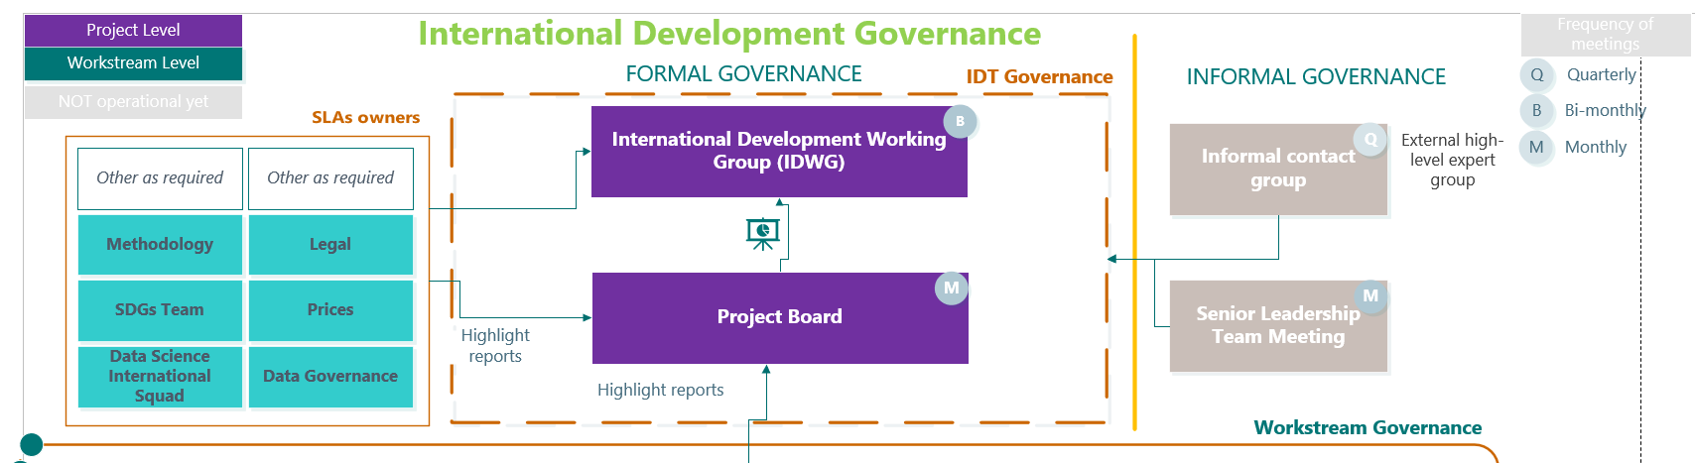

Key roles and responsibilities
The project team comprises:

- A pool of strategic advisors leading engagement with our partner organisations
- A project management team that leads on project management, financial management and results and risk monitoring, and evaluation, both at project and at partnership level
- An operations and policy team that ensures effective operational and logistical support
- A business development team that identifies new opportunities for the ONS to grow its international development profile in line with our overall strategy
- A technical assistance team that provides and sources ONS expertise for the programme. Expertise is sourced from across the ONS including through funded service level agreements (SLAs) and negotiated bilaterally with relevant business areas.

Benefit Realisation Arrangements
The project’s benefits will be captured in a results framework structured using the Theory of Change results statements for outputs, intermediate and long-term outcomes (see Figure 1). The framework contains indicators aligned with these results statements to measure benefits, with clearly defined targets, modes of data collection, frequency of reporting and responsible person(s). While the IDT’s monitoring, evaluation and learning lead has oversight of the framework, the project management team, strategic advisors, and other stakeholders within the ONS will all have a responsibility to contribute to the maintenance of the results framework. A review of progress towards our results (benefits) is a standing agenda item at monthly project board meetings. Benefits will be published on a yearly basis as part of the project’s annual review process.

Risk Management Arrangements
Risk management arrangements for the programme are based on the ONS’s Risk Management Framework (published internally November 2022).
Project level. The project risk matrix (Annex C) identifies the major risks and issues to overall project delivery, assesses their likelihood, impact, and severity, and sets out mitigations in place to reduce either their likelihood or impact. The co-leads of the ONS’s International Development Team are accountable for risk management and responsible for strategic and directorate level risks. The project management lead is responsible for monitoring project-level risks. The overall risk matrix is approved by the International Development Working Group. The project-level risk matrix is reviewed by the IDT senior management team monthly, and updates are provided to the International Development Working Group on a bi-monthly basis. High scoring project risks (12 or above) are escalated to the project board. If they cannot be managed at project level, they are escalated to the International Development Working Group. A risk dashboard is produced for the monthly project board to identify trends, movement in risk scores and ensure the programme’s risk profile remains within the appetite of the directorate.
Partnership level. A risk matrix sets out the risks specific to each partnership which the project managers are responsible for updating. These will be developed in conjunction with FCDO colleagues in-country and others with an understanding of the context as well as the ONS’s and wider UK Government’s appetite/tolerance for risk in that context. The RAID log is a live document to track risks, assumptions, issues and dependencies, managed as part of project managers’ day-to-day roles. Risks and issues are logged as soon as they are identified. Any changes to risk rating are reported to the project board.

Monitoring and Evaluation
The project has a Theory of Change that is reviewed every six months, and a results framework, with clear indicators, targets, and data collection methods. Results will be published on Devtracker yearly. Progress towards results is reviewed monthly by the project board.
A monitoring, evaluation and learning lead is responsible for developing and managing the monitoring and evaluation (M&E) system and for ensuring that the data collected, and results reports meet the required ODA transparency requirements standards. All staff funded through this project have responsibilities to collect and report information to the M&E system. The project will also commission an external evaluation at the end of the project.

Annex A - References
Reviews of previous phases of the programme:
- PMOS review - Review of the ONS/FCDO Programme for Modernisation of Official Statistics (PMOS), Final Report , 4 October 2021, Delphic Consultancy Limited, Nairobi – see Microsoft Word - PMOS Review - Final Report 4 Oct 21.docx (fcdo.gov.uk) posted at DevTracker Programme GB-GOV-1-300443 Documents (fcdo.gov.uk),
- Annual reviews of ‘pilot phase’, DFID. See DevTracker Programme GB-GOV-1-300443 Documents (fcdo.gov.uk)
- Annual review of the ONS’s Partnership Programme with international National Statistics Institutes for the modernisation of official statistics 2021-2022, ONS Planning and Portfolio Management team

Papers on Statistical Capacity Building
- Partnerships and Financing for Statistics: Lessons Learned from Recent Evaluations, Open Data Watch, June 24, 2015
- Paris 21 – Capacity 4.0 2017 Capacity Development 4.0 | Paris 21
- Roadmap for the Transformation and Modernisation of official statistics in Africa 2023-2030, https://repository.uneca.org/handle/10855/49338
- Global Partnership for Sustainable Development Data Theory of Change Narrative, 2019
- Measuring Capacity, UNDP 2010

Annex B - Delivery Plan
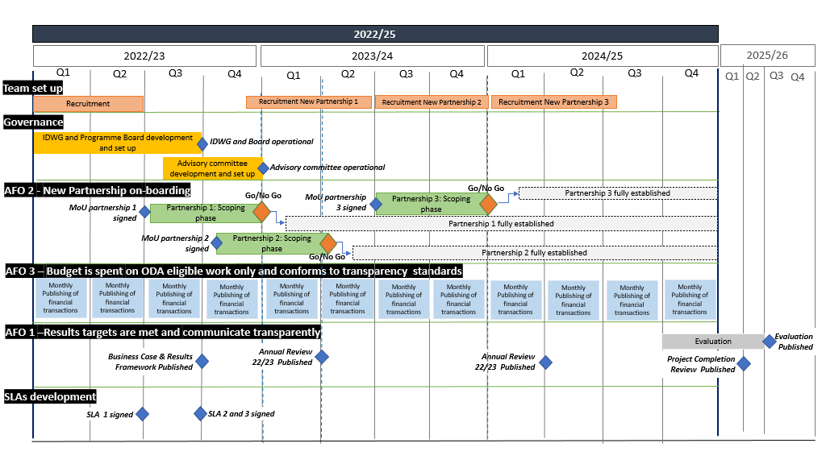

Annex C: Risk Matrix

Risk ID & Description (There is a risk that…) | Causes (Because of…) | Impact (Resulting in….) | Original likelihood | Original impact | Original score | Target likelihood | Target impact | Target score | Approach | Mitigations
The ONS/HMG is associated with (real or perceived) manipulation of data or other inappropriate activities | Our partners' organisational positions and systems could be considered less firmly and independently established, and more susceptible to political interference and pressure | Damage to the ONS or wider HMG reputation, and damaged relationships with partners | 3 | 3 | 9 | 2 | 2 | 4 | Treat | 1. Continually monitor risk at country level, and assess policy to engage with partner, especially if engaging with new partners  2. If accusations occur, liaising with FCDO, consider undertaking independent assessments of accusations, and/or withdrawing from pieces of work, where advised  3. Ensure our work focusses on technical areas and avoids political discussions  4. Include, where appropriate, advice on areas including legal, policy, code of practice, and communications  5. Develop and communicate policies relating to data ethics for our international development work
Ability to deliver is limited by partners’ competing priorities and limited capacity to fully engage with the programme in the agreed timescales. | There are wider constraints than those the programme can tackle | Low impact of the programme, and less commitment from the ONS or wider HMG in this or future IDT programme | 4 | 3 | 12 | 3 | 2 | 6 | Treat | 1. Use of theory of change to map outputs, outcomes and assumptions, and continual monitoring of these, reviewing when major changes to the context occur.  2. Jointly developing, monitoring, and adapting workplans with partners  2. Regular (remote, if needed) catch ups on partnerships' aims and objectives with partner management and other key stakeholders.  3. Ensure that technical assistance, especially short-term, is targeted appropriately with clear deliverables and in line with results framework and workplan.  5. Assess in country capacity to absorb technical assistance before work starts, including a realistic assessment of any barriers that may affect delivery (including mechanisms for delivering effective TA remotely).  6. Lead Advisors and short-term experts engage remotely with senior leaders early on to understand their needs and concerns.  7. Flex and adapt the workplan to focus on areas where conditions are appropriate.  8. Accept that there are peaks and troughs in each individual project / partnership and manage resources at a portfolio level.  9. In-country staff forming strong relationships with the senior leadership, enabling them to understand the context, priorities, and absorptive capacity, and ensure the activities are designed and delivered appropriately.
Partners do not support this programme and it loses momentum | Low absorptive capacity  Lack or comparability between contexts  ONS is unable to provide expertise with relevant understanding of context | Inability to carry our workplan and frustration on both sides | 3 | 5 | 15 | 2 | 5 | 10 | Treat | 1. Align behind national strategies and maintain continued dialogue and responsiveness with partners, adapting priorities where needed.  2. Effective coordination with other donors and monitoring the overlapping areas of interest.  3. Maintain a thoughtful balance between promoting areas where the UK/ONS is strong and continuing to be partner-led  4. Ensure that ONS staff are fully briefed on the political economy of the country in question before deployment, and that after deployment, the work with FCDO staff in-country to deepen their understanding of the political economy.
Fraud or corruption occurs | Poor management and monitoring of programmes | Loss of funds or  Poor value for money | 3 | 5 | 15 | 1 | 5 | 5 | Treat | 1. Ensure ONS follow government procedures and best practice  2. Ensure ONS has strong oversight  3. Design programme so that the ONS manages all procurement and does not provide funding, reducing the risk of fraud  4. Ensure ONS staff are briefed on areas of potential or likely fraud and corruption in-country and understand how to handle any arising risks/ issues.
The security, health, safety and wellbeing of ONS staff, partners or others associated with the programme is not maintained | Exposure to widespread global locations, working conditions, security threats, environmental and other hazards. And a range of potential experiences and power dynamics inherent in international development work | Injury and harm (physical and psychological) or death to ONS staff and people associated with the programme.  Inability to hire staff  Damage to ONS and One HMG reputation | 4 | 5 | 20 | 3 | 5 | 15 | Treat | 1. Work closely with FCDO to assess and manage risks for staff - applying FCDO standards where possible  2. Ensure that all ONS staff adhere to ONS IDT policies related to safety, security and safeguarding  3. Continually assess and improve IDT ONS policies (insurance a priority to resolve)  4. Ensure that we follow appropriate safety and security procedures for staff and short-term visitors to country in line with country procedures and consider similar levels of care for visitors to the UK  5. Ensure ONS staff/visitors are well-briefed and trained in mitigation of health, safety and security risks and safeguarding. This includes SAFE trained where necessary, FCDO 'Working Internationally' training and the provision of ad hoc advice directly.  6. Implement Head of Mission line management and other relevant alignment policies to improve support for staff based in country - ensuring roles and responsibilities clear and that people do not slip between cracks  7. Implement a clear safeguarding policy and procedures in line with HMG policy to protect all who come into contact with the IDT programme from harm, abuse and neglect.  8. Ensure that the working internationally code of conduct, roles and responsibilities and reporting concerns mechanisms are communicated to all ONS staff and associated personnel, NSO partners, and shared publicly.  9. Ensure all staff who travel overseas have Security Clearance.  10. Ensure relevant ONS and IDT governance and management oversight and procedures are in place  11. Ensure all staff involved in the project adhere to the ONS Code of Practice at all times.
Staff in IDT become burnt out and frustrated | High and difficult workloads, long hours and travel, and isolation (for those overseas) | Inability to hire staff  Damage to reputation  Anxiety or other mental health challenges to staff | 4 | 3 | 12 | 2 | 3 | 6 | Treat | 1. Monitor workloads and hire additional resources where required  2. Monitor staff wellbeing  3. Develop and deliver resilience training and arrange mentors when helpful  4. Develop appropriate systems to manage communications mechanisms to support travellers effectively without inappropriate burden on staff
Our future budget is not secured | Lack of certainty around ODA budget and next Spending Review settlement | Programme not being funded or funded less | 2 | 5 | 10 | 1 | 4 | 4 | Treat | 1. Regular contact with FCDO and HMT over SR plans - ensuring our programme aligns to HMG priorities  2. Broadening sources of funding  3. Ensuring future governance structures are effective

Phase 1: DevTracker Project GB-GOV-1-300443; Phase 2: DevTracker Project GB-GOV-24-001; Jordan project: DevTracker Project GB-GOV-52-CSSF-06-000033
https://www.oecd.org/development/financing-sustainable-development/development-finance-standards/officialdevelopmentassistancedefinitionandcoverage.htm
For example, the UN system, World Bank, Global Partnership for Sustainable Development Data, Paris 21, and NSOs including from Sweden, Denmark, and Canada
See references section, papers on statistical capacity building, especially Paris21, UNDP and UNECA references
There are four considerations that all ODA funded programmes must comply with: 1. DO undertake Climate Risk Assurance (as part of the joint Climate and Environmental Risk Assurance where required); 2. DO use shadow carbon pricing in programme appraisals (where required); 3. DON’T invest in fossil fuels and 4. DON’T develop programming that goes against a country’s climate plans
See Energy consumption - Office for National Statistics
Review of the ONS/FCDO Programme for Modernisation of Official Statistics (PMOS), Final Report , 4 October 2021, Delphic Consultancy Limited, Nairobi – see PMOS Review - Final Report 4 Oct 21
Open Data Watch, 2015
uksa.statisticsauthority.gov.uk working internationally
For example see: Roadmap for the Transformation and Modernisation of official statistics in Africa 2023-2030, https://repository.uneca.org/handle/10855/49338
South-South cooperation explained | UNICEF China
ONS internal survey. 79% strongly agreed and 16% agreed.

