PROBLUE: Annual Review, FY 2021/2022

Title: PROBLUE
Programme Value £ (full life): £25,000,000 |  | Review date: October 2022
Programme Code: BPFPROB | Start date: November 2021 | End date: March 2026

Summary of Programme Performance
Year | FY21/22 | FY22/23 | FY23/24 | FY24/25 | FY25/26
Overall Output Score | A
Risk Rating | Med

DevTracker Link to Business Case: | TBC
DevTracker Link to results framework: | TBC

Contents
Abbreviations 4
Section A: Programme Summary/ Overview 4
A1. Programme Description 4
A2. Supporting Narrative 5
A3. Lessons learnt and recommendations 5
Section B: Progress review 8
B1.1 Summary 8
B1.2 Theory of Change 10
B2. Assessment of whether programme is on track 11
B3. Recommendation on whether programme should continue 12
Section C: Output assessment 13
Section D: Risks 19
Section E: Programme Management 22
E1: Summary of Defra and delivery partner performance 22
E2: Value for money overview 24
Annex 1a: Supporting Narrative 25
Annex 2a: PROBLUE (Operational Level) Theory of Change & 28
Annex 2b: PROBLUE Assumptions, risks and mitigations 29
Annex 2c: Key insights into progress through outcomes and outputs (Y1) 31
Annex 3: Blue Planet Fund Theory of Change 32
Annex 4: Output scoring 33

Abbreviations

Acronym | Spelled out
BC | Business case
BETF | Bank Executed Trust Fund
BPF | Blue Planet Fund
CMAR | Corredor Marino del Pacífico Este Tropical
Defra | Department for Environment, Food and Rural Affairs
FiTI | Fisheries Transparency Initiative
FY | Financial Year
GPS | Global Programme on Sustainability
HMG | His Majesty’s Government
IFC | International Finance Corporation
KPI | Key Performance Indicator
LDCs | Least Developed Countries
Logframe | Logical Framework
MPA | Marine Protected Area
MSP | Marine Spatial Planning
MTR | Mid-Term Review
ODA | Official Development Assistance
PMO | Project Management Office
RETF | Recipient Executed Trust Fund
SDG | Sustainable Development Goal
SIDS | Small Island Developing States
ToC | Theory of Change
UK | United Kingdom
VfM | Value for Money
WBG | World Bank Group
XWH | Cross-Whitehall

Section A: Programme Summary/ Overview

A1. Programme Description
PROBLUE is a world bank multilateral mechanism to facilitate sustainable ocean activities for which the United Kingdom is a leading contributor. It works to support the development of blue economies across Small Island Developing States (SIDS) and coastal Least Developed Countries (LDCs). PROBLUE covers 4 pillars which are: fisheries & aquaculture (improving management to address overfishing & strengthen aquaculture sustainability), preventing & managing marine pollution (addressing threat of litter, plastics & other land-based pollution), oceanic sectors (‘blueing’ traditional & novel oceanic sectors to limit adverse impacts on ocean health) & integrated seascape management (making management of coastal & marine areas more sustainable & more integrated). The pillars are thematically distinct but are approached in an integrated way under the framework of pillar 4. PROBLUE’s predominant vectors are currently common approach tools such as Marine Protected Areas (MPAs), Integrated Coastal Zone Management & Marine Spatial Planning (MSP).
In Financial Year (FY) 2021/2022, the UK funded PROBLUE from the Blue Planet Fund. Total funding for this year was £8 million of Official Development Assistance (ODA), which comprised an initial £6 million followed by a £2 million uplift. This uplift was preferenced for spend in the Eastern Tropical Pacific which included the marine and coastal resources of four countries: Costa Rica, Panama, Colombia, and Ecuador, also referred to as the CMAR region.

A2. Supporting Narrative
This reporting year (FY 2021/2022), highlights include:
- Supporting the Aquabusiness Investment Advisory Platform, designed to support best practice development for economic, social and environmental sustainability through technical assistance and International Finance Corporation (IFC) advisory services.
- Supporting the FiTI (Fisheries Transparency Initiative), a global partnership for transparency and participation in management of marine fisheries. As part of this, the first two FiTI candidate countries – Mauritania and the Seychelles published their second reports in FY22.
- Supporting Regional efforts to tackle Marine Plastics Litter across the ASEAN region. This has seen a Regional Action Plan for Combatting Marine Debris developed which integrated guidelines for promoting gender equality & critical analysis studies. This has been endorsed by all 10 ASEAN members.

We welcome the independent Mid Term Review of March 2023 being undertaken by KPMG and look forward to incorporating the results into PROBLUE going forward.
The programme score for FY 2021/2022 is A, Outputs met expectations. This has been assessed through output scoring (please refer to sections B2, B3, C for details).

A3. Lessons learnt and recommendations
Lessons learnt
- This Financial Year, PROBLUE absorbed an additional £2 million of Official Development Assistance (ODA) from the Blue Planet Fund. The £2m was preferenced for spend in the CMAR (Eastern Tropical Pacific) region, however, engagement with key stakeholders has been slower at times than anticipated. In future, we will seek to build in more CMAR-focused regular communication and updates and following recent discussions, the regional PROBLUE leads have agreed to this strengthened engagement.
- PROBLUE is one of three environment/ nature focused trust funds that Defra and the WBG collaborate on. Others include PROGREEN and GPS (Global Programme on Sustainability). GPS has a longer-standing relationship with the WBG. In future, we are keen to maximise the collective work across the three trust funds, including aggregating programme outcomes to ensure impact and learning, and engagement across in-country partners/ministries. A more strategic change approach that considers GPS & PROGREEN should help guide and mainstream PROBLUE investments within the broader nature/ biodiversity landscape. We will also look to better align PROBLUE projects with broader BPF and UK programming and share lessons between them. We are in the process of developing a logframe, drawing from current PROBLUE reporting tools to allow a more accurate picture in future of the impact that Defra funding is having on PROBLUE programming.
- We are keen to ensure a range of views are considered through the delivery of PROBLUE, including from recipients and client countries, and will continue to encourage this moving forward. The output from the Gender Working Group (of which the UK is a member) has successfully driven forward a focus on gender and given guidance to the Secretariat (and the Bank more generally) on how to better integrate gender awareness in project planning. Based on the findings of the MTR, (especially around the cross-cutting themes of Fragility, Conflict & Violence), we will, alongside other Partnership Council members, consider introducing additional working groups. We are keen to build on the positive developments this year in relation to communications, for example, engagement from PROBLUE ahead of international engagements at COP27 & CBD15. Moving forward we want to ensure consistent join up between donors and the Secretariat to properly take advantage of opportunities.
Recommendations
- Logframes and Theory of Change:
  - To improve auditing and accounting for PROBLUE, we will review the current reporting offered by the Secretariat (e.g., through the DP tool) and compare this against the KPIs set out in the Business Case/wider BPF and ICF KPIs. This will be used to finalise the PROBLUE logframe, as well as a more comprehensive Theory of Change ahead of next year’s Annual Review.
  - Work with the Secretariat and Partnership Council to ensure PROBLUE targets are sufficiently ambitious.
- Build on recommendations from the independent MTR (for example around a sequential approach for project selection) and use these to work with the Secretariat and Partnership Council to deliver greater impact through PROBLUE.
- A greater focus on collaboration and coherence:
  - To optimise efficiency in delivery and synergies across UK and global biodiversity & sustainability programming, we propose stronger collaboration with Defra teams leading on other areas of World Bank programming such as PROGREEN and GPS. This will require support from the respective UK programming teams. Seek opportunities to learn from and make links between PROBLUE projects and other BPF programmes on a country or regional basis. This should increase the coherence of the UK offer in countries.
- Use our membership and role as co-chair to encourage PROBLUE to enhance partner collaboration and optimise communication between the members of the partnership council, facilitating discussion on learnings and connections across the donors. Increased communication and engagement will support collaboration over programme delivery where the work of PROBLUE overlaps with other programmes managed by HMG, e.g., CMAR in the Eastern Tropical Pacific region.
- Through UK investment into PROBLUE, support the World Bank’s commitment to drive MDB reform and align with COP 26 commitments on nature positive finance and the Global Biodiversity Framework, e.g., implementation of 30 x 30.

- Where there is an identified gap (e.g. as a result of the MTR), discuss the potential with other partners to establish an additional cross-cutting working group(s).

- Moving forward, we would like more consistent advance notice of comms plans, particularly around big set pieces/ conferences, with better communication and coordination with comms focal points (suggest meetings on an ad-hoc basis related to key events or engagement opportunities between donors and comms).

Section B: Progress review

B1.1 Summary
This Annual Review marks the end of the first year of investment into PROBLUE through the Blue Planet Fund. A 5-year business case was signed off in September 2021, with ambitious deliverables agreed internally. Moving forward, we need to make better use of the reporting measures the World Bank has in place to audit and measure progress. We will draw from those indicators outlined in the Business Case and compare these against the reporting conducted by PROBLUE to ensure clear achievable outputs and ambitious, measurable targets. The updated indicators will then be reported against in the 2022/23 Annual Review.
The pathways to achieving outcomes and impact are detailed in Theories of Change (ToC) in section B2. Our provisional first ToC (B1.2.1) describes how the UK’s inputs - including financial, strategic and high-level advocacy support –assist PROBLUE with delivery of their outputs, outcomes and impacts, which are described in the second ToC (B1.2.2). These Theories of Change feed into the overarching Blue Planet Fund ToC (Annex 3) which was developed at the outset of fund design and identifies improved marine biodiversity, improved resilience, adaptation, and mitigation of climate change and tackling marine pollution as three of the four primary thematic outcomes.
Our PROBLUE Theories of Change will be further developed in line with the development of an internal PROBLUE logframe. This will be developed through extrapolating PROBLUE progress (as outlined in resources such as the Annual Report and the DP Tool) against the percentage total of PROBLUE funding that comes from Defra (currently 3.8%). As described in section B2, PROBLUE are delivering on these pathways to meet expected output and outcome targets for this review period. This allows confidence that the impacts to be realised in the long-term are on track, and that PROBLUE will offer VfM as the value of these benefits is expected to outweigh the initial investment.
PROBLUE successfully delivered projects which amounted to their primary allocation of £8 million. The UK, as a donor partner, can express preferences for which of the trust funds under the PROBLUE umbrella we invest in, which we have done in relation to projects in the Eastern Pacific. The multi-donor trust fund approach means that a fully disaggregated view is not possible. However, the UK’s position on the Partnership Council and our relationship with the World Bank and the PROBLUE secretariat allows us to work together to shape the strategic direction of the programme. The programme itself has been running since 2018, and to date almost all projects have been BETFs (Bank Executed Trust Fund) with a primary focus on analytical and technical support. This Financial Year, (FY22), three Recipient Executed Trust Fund (RETF) projects have been trialled in the eastern Caribbean, Cambodia & Cabo Verde. In line with the wishes of the Partnership Council, the PROBLUE secretariat are looking to support an increasing number of RETF projects.
As we move into the next reporting year, the UK has a continued role to play in progressing these programme outcomes, as shown in the ToC (section B1.2.1). PROBLUE is at an important junction and there are significant opportunities for governments and non-state actors to scale up their ambitions for ocean biodiversity, in line with SDG 14 conserve and sustainably use oceans. Additional collaboration and concerted effort will be needed to realise PROBLUE’s ambitions across the four pillars and maximise the potential for poverty reduction, improved livelihoods, improved gender outcomes, climate change mitigation and increased development finance, in line with the cross-cutting themes. We will be working with stakeholders including UK Ministers, World Bank operatives and other donor partners to push for action across the public and private sectors.

B1.2 Theory of Change
Blue Planet Fund (UK) input into PROBLUE: Theory of Change
Note that we are in the process of developing an internal logframe which will inform the development of a more comprehensive Theory of Change in the future.
See Annex 2 for PROBLUE Theory of Change, Assumptions, risks and mitigations and BPF Theory of Change.
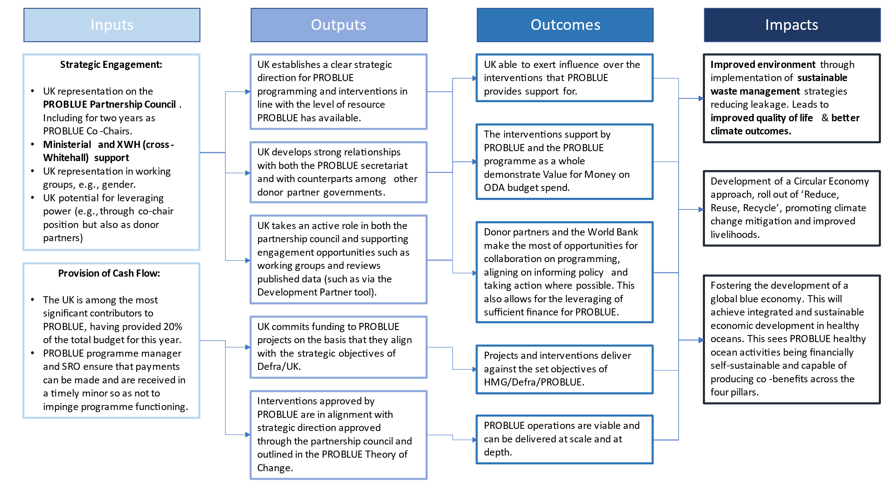

B2. Assessment of whether programme is on track
Within the last year, PROBLUE has taken a hands-on approach to global crises from Covid-19 to the impacts of climate change. This has seen PROBLUE supporting the post-Covid recovery of some of the poorest countries, with a focus on resilient and integrated management of marine and coastal resources to drive economic recovery.
The output assessment (section C) provides quantitative scores to reflect whether the programme is on track based on key outputs agreed between Defra and WBG at the outset. We have taken these from the PROBLUE Annual Report. All 3 outputs used by the World Bank have either met or exceeded expectations across their indicators, albeit against what we consider conservative estimates. How knowledge products/ tools have been used and the extent to which, for example, they have contributed to more informed policy and decision making, needs further assessment going forward.
Tools
We are pleased to note PROBLUE has delivered a strong performance as regards number of tools, going forward, we hope to see even greater ambition from the World Bank on these targets where possible.
Examples of global tools PROBLUE have supported include a database and toolkit for MSP, a database for maritime transport costs, a methodology for cost-benefit analysis in aquaculture regarding biosecurity and a rapid Water Sanitation & Hygiene (WASH) needs assessment.
More detail on tools can be found in Section C.
Knowledge Products
PROBLUE has achieved more than double the number of knowledge products against the target set.
Examples of knowledge products PROBLUE have helped develop include:
- A report analysing the marine litter footprint and assessing circular economy opportunities in Mozambique
- Assessment of pollution and plastic transmission in the Yangtze River, publication on qualitative and quantitative analysis of sources contributing to waste and leakage mechanisms in China
- National assessment of plastic waste management in India

Examples of regional and global knowledge products PROBLUE have helped develop include: a series of technical reports on decarbonisation of shipping, baseline report on pollution in the Black Sea, Pacific Country Management Unit marine plastics action plan, global shipping traffic density dataset, publication coupling a deliverable on (i) global sustainable and resilient tourism on small islands and in coastal destinations; and (ii) sharing qualitative market research findings and a factsheet on gender, marginalised people and MSP.
More detail on knowledge products can be found in Section C.
We will gain a greater understanding of the impact of PROBLUE outputs to date through the findings of the Mid-Term Review (due to be published in full in March 2023, with initial results being circulated in January 2023).
Based on the evidence summarised in table i and section B2, we are moderately confident that the commitments made by PROBLUE are on track for delivery. Of the targets set by PROBLUE, the programme has generally performed well. These targets are set by PROBLUE in reference to programme outputs. These include both targets for activities that support the sustainable blue ocean directly and ‘catalysing World Bank Operations’ which contributes to other goals beyond the scope of PROBLUE. We can therefore conclude that the expected impacts (i.e., improved environment and improved quality of life for communities impacted by pollution) will be realised. More work is needed to disaggregate the impact of Defra funding in programme performance data provided to us by the World Bank.

B3. Recommendation on whether programme should continue
Based on the output scoring (sections B1, C), there is sufficient evidence that the programme represents good VfM. All 3 output indicator targets were exceeded, despite the global challenges for ocean financing. However, we would welcome more ambitious targets from PROBLUE moving forward.
As part of next steps for continued funding for PROBLUE, we are in the process of developing a logframe which will allow us to better understand and appreciate the impact of the longer-term outcomes of PROBLUE activities and record these in future Annual Reviews.
Defra recommends that this programme should continue.

Section C: Output assessment
Capacity Building

As outlined above, PROBLUE successfully completed more than 3 times as many capacity-building activities as were planned at inception.
Types of events offered include training workshops, awareness-raising activities, seminars, knowledge events, validation consultations, stakeholder consultations, national workshops and webinars.
A specific example is the week-long webinar organised by PROBLUE with stakeholders as part of the ‘Fisheries Status Assessment Toolkit’ funded by the programme.
Defra’s contribution to the PROBLUE fund at present accounts for 3.8% of the total fund and as such, we can extrapolate that 3.8% of the outputs currently produced by PROBLUE are attributable to Defra funding.
The output indicators detailed in table i are from the PROBLUE Annual Report, which was developed in September 2022 and includes details from every other Annual Report (back to FY 2018). The outputs have been scored in the table according to whether their quantitative targets were met in FY 2021/2022, in accordance with the findings of the Annual Report. The indicators they outline are activities, which serve as provisional examples of what the programme has achieved so far, for the benefit of the Partnership Council. A Mid-Term Review is currently in progress which will offer further details we can draw on in future Annual Reviews.
The PROBLUE Annual Report divides its outputs across three key indicators: capacity building activities, tool developed, and knowledge products prepared.
The Annual Report also covers a summary of approved BETF proposals (which are broken down into the cross-cutting themes of gender, climate change, Mobilising Finance for Development (MFD) and Fragility, Conflict & Violence (FCV) and the catalysing of World Bank Operations. There indicators provided for RETF activities as well, however given that these were only piloted over the last year, there are not baseline values set yet and no data to measure performance.

Output Title | Working with local, regional & national stakeholders to conduct various capacity building activities
Output number: |  | 1 | Output Score: | A
Impact weighting (%): |  | 33.3 | Weighting revised since last AR? | N/A

Indicator(s) |  | Baseline | Target (end of programme FY26) | Actual (FY22)
1.1 | # of workshops, trainings and consultations conducted | 0 | 150 | 360

Example output: Cleaner Marine and Coastal Ecosystems in North Africa regional workshop where participants from the Middle East, North Africa and West Africa shared and learned from national experiences in developing action plans to achieve this aim.
This links with BPF KPI number of marine-related evidence, knowledge dissemination and education activities or products developed as a result of BPF finance. In the longer term, it will also contribute to other BPF KPIs such as number of new or strengthened policies, strategies or regulations related to improving or managing the marine environment and area of marine ecosystems protected, enhanced or sustainable management practices as a result of BPF projects.
In relation to capacity building outputs, this year there have been 19 completed while 48 remain ongoing. The target for activity proposals (for completed projects) was 39 while the amount achieved was 141. This has produced an achievement against activity target (in percentage terms) of 362%. For ongoing capacity building activities, the target was 184 while the amount achieved was 219 for an achievement against activity target of 119%. Thus, in capacity building activities, PROBLUE is exceeding against expectations against the indicators.

Output Title | Developing and implementing tools to provide and support analysis and policymaking.
Output number: |  | 2 | Output Score: | A
Impact weighting (%): |  | 33.3 | Weighting revised since last AR? | N/A

Indicator(s) |  | Baseline | Target (end of programme FY26) | Actual  (FY22)
2.1 | # tools developed | 0 | 50 | 68

Examples of global tools include:
- A database & toolkit for MSP
- A database for maritime transport costs
- A methodology for cost-benefit analysis in aquaculture regarding biosecurity

Examples of regional tools include:
- Technical and economic feasibility study guidelines for plastic waste recycling plants
- A toolkit on metrics to measure plastic waste in East Asia and the Pacific

Examples of national tools include:
- An input-output model for environmental-economic analysis in Fiji
- Guidelines and rules to minimizes plastic packaging in Bangladesh
- A plastics life-cycle assessment framework for cities in India
- A survey tool on plastic waste perception and behaviour in the Maldives

The results of outputs on activities around tools is that 20% of PROBLUE’s current portfolio of activities have achieved 68 tools developed against an end-of-programme target of 50. This overperformance may lead PROBLUE to re-evaluate whether it has been sufficiently ambitious in some of its aims.
This also links with BPF KPI number of marine-related evidence, knowledge dissemination and education activities or products developed as a result of BPF finance. In the longer term, it will also contribute to other BPF KPIs such as number of new or strengthened policies, strategies or regulations related to improving or managing the marine environment and area of marine ecosystems protected, enhanced or sustainable management practices as a result of BPF projects.
Concerning the output activities related to tools, this year there have been 17 completed with 30 remaining ongoing. The target for activity proposals (for completed projects) was 28 while the amount achieved was 34. In percentage terms, this represents an achievement against target percentage of 121%. For ongoing activities, the target was 50 while the amount achieved was 34, giving a percentage achievement against activity target of 68%. This means that PROBLUE is meeting expectations on Tools activities, against targets.
Indicator 2.1 exceeded its target in ratio terms, and we have awarded PROBLUE an A – output met expectations. We are also not yet able, based on the currently available evidence, to evaluate the ‘implementation’ of these tools.
Output Title | Preparation and utilisation of knowledge products to support stakeholder decision-makers and inform action.
Output number: |  | 3 | Output Score: | A
Impact weighting (%): |  | 33.3 | Weighting revised since last AR? | N/A

Indicator(s) |  | Baseline | Target (end of programme FY26) | Actual  (FY22)
3.1 | # of knowledge products prepared | 0 | 100 | 236

Examples of knowledge products produced by PROBLUE include:
- A report on the private sector and fisheries in Mozambique
- A report on blue economy financing mechanisms in Mozambique
- A national strategy on plastic-free coastlines and an operational action plan for Morocco
- Building strategies with innovative measures for plastic-free seas and oceans in China
- Vietnam market study on plastics circularity
- Addressing mismanaged plastics in Kerala, India
- Vulnerability assessment reports and mangrove status reports from Ghana & Guinea

The PROBLUE programme has been driving for greater consistency in the approaches used for knowledge products and analysis tools, guiding strategic efforts to develop integrated and sustainable economic oceanic activity with healthy oceans.
This also links with BPF KPI number of marine-related evidence, knowledge dissemination and education activities or products developed as a result of BPF finance. In the longer term, it will also contribute to other BPF KPIs such as number of new or strengthened policies, strategies or regulations related to improving or managing the marine environment and area of marine ecosystems protected, enhanced or sustainable management practices as a result of BPF projects.
On knowledge product activities, there have been 19 completed this year, while 48 remain on-going. The target for completed activities is 30 while 63 have been achieved, a percentage of 210% of the targets. The target for ongoing activities was 262 while 173 were achieved, a percentage of 66%. As such, PROBLUE is exceeding against expectations under the indicators.
Taking the total number of indicator activities conducted in the FY22 (236) against the currently invested Defra funding level of 3.8% of the total PROBLUE fund allows us to extrapolate that Defra funding has supported 8.968 of these tools being developed.
While we note relatively impressive performance here against targets, again we would like to see more ambitious target setting from PROBLUE moving forward. At this stage, it is also difficult to assess the utilisation of knowledge products or how these have contributed to stakeholder decision-making. We are also expecting more detailed reporting to come from the publication of the Mid-Term Review in March 2023 and in future will be incorporating these findings into future Annual Reviews. This will in part reflect on the experiences of stakeholders giving us greater insight into the impact of these knowledge products. We have awarded this output a score of A – output met expectations.

BETF Proposals approved
While the number of project proposals to PROBLUE for funding has been declining in the past two Financial Years, the Annual Report notes that this is largely due to increased complexity and larger funding demands of more recent approved proposals.
These indicators do not directly correlate to outputs; however they do serve as a measure of the pipeline of activities PROBLUE has approved and that types of projects that will be available to review in future Annual Reviews.
In total this year PROBLUE approved 30 new BETF projects with a total value of $18.3m.
Output Title | Approving PROBLUE-supported BETF proposals with focus, analysis and approaches on gender awareness, climate change, MFD & FCV
Output number: |  | N/A | Output Score: | N/A
Impact weighting (%): |  | N/A | Weighting revised since last AR? | N/A

Indicator(s) |  | Baseline | Target  (end of FY 26) | Actual (FY 22) - with % of all FY 22 projects approved
1 | Approved PROBLUE-supported proposals with gender analysis and gender-focused approaches and strategies | 0 | 120 | 23 (77%)
2 | Approved PROBLUE-supported proposals with climate change specific data and analytics | 0 | 120 | 30 (100%)
3 | Approved PROBLUE-supported proposals with MFD-specific data and analytics | 0 | 75 | 18 (60%)
4 | Approved PROBLUE-supported proposals relevant to FCV context | 0 | 50 | 5 (17%)

Improving gender outcomes is a cross-cutting theme of PROBLUE and the secretariat has committed significant resources to ensure that gender impacts are integrated into programming. This has taken the form of dedicated staff leads who have worked with the Donor Partners through the Gender Working Group. We are pleased to note that 77% of the new BETF projects approved this year feature gender analysis and gender-focused approaches and strategies. We also note that, to date, PROBLUE have approved 104 proposals with gender analysis and gender-focused approaches and strategies against an end-of-programme (FY26) target of 120. It seems likely that they will exceed this target.
Climate change is another cross-cutting theme of PROBLUE. We are pleased to see that 100% of the proposals approved this year had climate change specific data and analytics, up from 90% the previous year. We also note that, to date, PROBLUE have approved 113 proposals with climate change specific data and analytics against an end-of-programme (FY26) target of 120. They are therefore likely to exceed this target.
In relation to Mobilising Finance for Development (MFD), while only 60% of the proposals approved this year featured MFD-specific data and analytics, we recognise that this is up from 55% the previous year. We also note that PROBLUE have approved 77 proposals to date with MFD-specific data and analytics and have already met their end-of-programme (FY26) target of 75. Given the strong performance so far, we feel there would be benefit in PROBLUE revising this target to make it more ambitious.
On Fragility, Conflict & Violence (FCV), only 17% of proposals approved this year were seen as relevant to an FCV context. PROBLUE acknowledges that they are behind in this area, having to-date approved 28 proposals relevant to an FCV context against an end-of-programme target of 50. We remain confident that PROBLUE will be able to meet this target and will work with the Secretariat and Partners to ensure focus on this area moving forward.
Overall:
The average score across the outputs, taking impact weighting into account, is A – Outputs met expectations. While the data currently available is encouraging, more work is needed internally in Defra to better understand and evaluate the impact of Defra funding into PROBLUE against the objectives of the BPF. We feel this can be addressed through continuing to work with the Secretariat to understand the impact that PROBLUE are having in-country. Given the early stage of delivery, we will also be able to better reflect on the impact of knowledge products and tools produced once sufficient time has passed (e.g., we should have an indication of some products and tools developed in FY22 by the time of our next Annual Review. This will also support our development of an internal logframe and a more comprehensive Theory of Change.

Section D: Risks
Risks are logged, managed and reviewed by the programme manager. Risks are categorised as either ‘delivery risks’ (i.e., the risk is associated with operations and activities in which PROBLUE is involved) or ‘management risks’ (i.e., the risk is associated with processes that are managed by the Authority).
Risk Description | Risk Category | Impact | Likelihood | RAG Status | Mitigating action(s), action completion dates and action owner(s) | Notes | Change since last year
PROBLUE projects may not be sustainable long-term due to insufficient uptake & investment by the private sector into PROBLUE projects, making them unviable long-term | Management: Delivery/ operational | High | Low | Medium | Programme manager and SRO are working together with PROBLUE to make sure that we are up to date with available evidence. We will also champion the issue of long-term sustainability of projects in discussions at the Partnership Council. | Mitigation in progress | Since last year, we have increased our engagement with the secretariat to improve our understanding of available evidence.  This Financial Year, the World Bank has increased its focus on Recipient-Executed (RETF projects) which present greater opportunities for a de-risked landscape for private investment.  Continued technical & analytical support from the World Bank offers opportunities for reduced risk in sustainable blue economic sectors, e.g., rapid assessment into blue carbon in Pakistan.
The structure of MDTF which limits granularity on where/ how UK funds are being spent may lead to the performance & delivery of the programme not meeting the targets or minimum requirements of the Blue Planet Fund. | Management: Delivery/ operational | High | Medium | Medium | See above working with PROBLUE to make the most of our position on the Partnership Council and working with other donors and the Secretariat to achieve our shared objectives. | Mitigation in progress | As above, we have made strides towards increasing our communication with the World Bank.  We are in the process of developing an internal logframe. Once this is agreed, we will be better able to capture the performance of PROBLUE activities against Blue Planet Fund targets.
Change in government may lead to decrease in political will and/ or less safe environments which could mean projects are delayed or cancelled. | Management: Delivery/ operational | Medium | Low | Low | In priority countries, seek stronger collaboration with teams on the ground, working through Post network and BPF regional advisers. Work with other donor partners to navigate productive solutions. Ensure projects have strong sustainability lens, including building capacity of civil society and local partners. | Mitigation in progress | Over the course of this year , several recipient governments have changed political administrations. There have been some indications of minor disruptions, but largely programming has been able to continue successfully.
Projects may not give enough attention to the cross-cutting themes (e.g., FCV, gender etc.) due to other competing pressures. | Management: Delivery/ operational | Medium | Medium | Medium | Again, maintaining clear communication is key. Another important action is to maintain coordinated effort in conjunction with the other donor partners through the Partnership Councils and any cross-cutting Working Groups. | Mitigation in progress | This year, Defra have taken a more active role in the Gender Working Group, working together with PROBLUE and other donor partners to ensure the most gender-positive outcomes from programming.  The Annual Report this year has also demonstrated considerable progress towards the development of Gender Action Plan, for example in Mozambique.
Across HMG, UK officials do not fully realise the potential to work across GPS & PROGREEN due to resourcing constraints & competing pressures. Across HMG, we are unable to fully engage with central World Bank leads (in FCDO) and across our Nature Finance MDB teams. | Management: Delivery/operational | Low | Low | Low | We are actively engaging with programme managers for PROGREEN & GPS to fully ensure join up and will establish regular engagements with them in 2023 to ensure we can learn lessons and aggregate impact. We will look to feed into and shape strategies and action plans across Whitehall. |  | Since last year, we have made a more active effort to engage with colleagues on PROGREEN & GPS, which has included being invited to meetings between Defra programme managers and World Bank leads. We are better engaged cross-Whitehall, including with BEIS & FCDO.
Table ii: Risks that have been identified and are the process of being mitigated in FY 2021/2022

Section E: Programme Management

E1: Summary of Defra and delivery partner performance
Delivery partner performance

Finance and reporting:
We do not have a fully disaggregated account of our funding because the structure of PROBLUE (as an MDTF) does not allow for this. We do have a well-established relationship with the World Bank (both on an HMG level and a Defra level). In addition to the regularly updated accounts, PROBLUE publish an annual report and have also contracted out a Mid-Term Review, which is due to be published in March 2023, with initial reports due to come out in January 2023. As mentioned, moving forward we will be looking to build an internal logframe drawing on the available data reporting (such as the DP tool) that PROBLUE provide to us. This will improve reporting and allow us to better track the progress of our role in PROBLUE. Putting these processes in place will increase financial probity and allow us to more thoroughly report on programme performance moving forward.

Communication:
PROBLUE Secretariat colleagues are supportive in their engagement and regular progress meetings and have been open and transparent in their communication with us. We need to do more internally to better understand and inform other Defra stakeholders of updates regarding progress (e.g., through the DP tool), although the steps we have taken so far have been positive, according to programme managers. Concerns around the slower implementation of the CMAR/Eastern Tropical Pacific preferenced activities and meetings to uncover the causes, have resulted in a clearer strategy this year for the CMAR programme of work. The regional lead has also agreed to give us more regular progress updates as and when activities develop.

We have agreed with PROBLUE managers that we will remain in contact with the regional leads for the Eastern Pacific so we can be aware of any significant developments. We are encouraged by the indicative timeline that has been provided, suggesting implementation will begin in early 2023. We are also hopeful that the lessons learned from this experience, both for ourselves and PROBLUE will be informative in mapping the way forward. For example, through ensuring we have a full understanding of PROBLUE’s strategic planning for any future preferenced spend. We will continue to engage with regional and thematic leads to track progress in this area and raise any concerns with the Secretariat.

Collaboration:
The team at Defra have found the PROBLUE team to be friendly, accommodating, professional, and passionate about their work. When Defra requires information from the delivery team, colleagues at PROBLUE are prompt to respond in full. They are available for meetings (subject to sufficient notice) and engage with the Blue Planet Fund/Defra programming mechanisms more broadly. They have also demonstrated interest and willingness to work with Defra to improve strategic alignment, create efficiencies and collaborate where necessary.

Defra programme team performance
Defra consulted the PROBLUE team for feedback regarding programme management.

They provided the following statement:
Soon after joining PROBLUE in 2021, DEFRA became the co-chair of the PROBLUE Partnership Council, bringing leadership and strategic vision to the program and greatly facilitating communication among the Partnership Council members. DEFRA is not only bringing financial contribution to PROBLUE, but it is also bringing its technical leadership on issues such as biodiversity and climate change. There is clear convergence between DEFRA’s priorities and the strategic direction of PROBLUE, and they strive to push for further ambition on the nexus between biodiversity, climate change, pollution and nature, which is most appreciated by the PROBLUE team. The DEFRA team has always been open for discussion and negotiations, and often brings innovative perspectives to the table. We are in regular communication, which allows for strategic discussions (e.g., around COP27, COP15) and also deep dives on particular topics.

E2: Value for money overview
Given the BPF has only invested in PROBLUE for one year, it is expected that successes associated with the Year 1 investment can only be presented at the output level rather than outcome or impact levels. Given the relatively early stage of programming, it is also currently difficult to assess outcomes of tools or knowledge products developed. In addition, the evidence as currently presented is insufficient to assess performance at an ‘outcome’ level. In the PROBLUE Business Case, the benefits of leaked plastics and emissions reduced, and the production of sustainable aquaculture were monetised. Investment at the current level was felt to offer the benefits of reducing poverty and improving the marine environment, as well as promoting sustainable aquaculture practices and sustainable oceanic sectors (not monetised) and supporting disaster preparedness (not monetised).
The business case identified a Net Present Value for our investment (of £25m over 5 years) of £29.4m - £136.3m and a partial benefit cost ratio of 2.4 – 7.5, demonstrating value for money.
The evidence in table i and section B2 shows that as far as can be determined, PROBLUE is meeting our expectations. If we are successful in agreeing a revised logframe with the PROBLUE Secretariat, we may see performance remain static, however, implementing more robust reporting and identifying areas of focus is an absolute priority and will enable us to develop performance related recommendations in future years. Given that World Bank reporting demonstrates a current leveraging ratio of 92:1 (in USD) we have confidence that the impacts of PROBLUE can be realised. This gives us confidence that PROBLUE will offer VfM as the value of the benefits is expected to significantly outweigh the initial investments, and this is supported by performance to date.

Annex 1a: Supporting Narrative

Highlights:
- Aquabusiness Investment Advisory Platform: This facilitates aquaculture production, nutrition and increasing quality jobs to move towards environmental sustainability, social and gender inclusivity, and economic equality. This has seen engagements launched in Cabo Verde, Cambodia, Côte d’Ivoire and Pakistan.
- The Fisheries Transparency Initiative: ProBlue is supporting the independent validation of these reports and has also supported promotional & awareness-raising activities which have led to three new countries joining FiTI: Ecuador, Madagascar & Sao Tome e Principe with a total of 7 countries engaged with improved fisheries transparency under FiTI.
- The conclusion of an analysis into reducing disease risk in aquaculture through health cost/benefit. This estimated losses from aquaculture diseases and provided a realistic estimate of the cost of implementing the five packages of interventions required to manage these losses. This included work in Peru, Vietnam and Sri Lanka.
- Rolling out the Fisheries Sector Assessment Toolkit, developed in FY0 – FY21. This has focused on the uptake of five tools: the Fisheries Performance Assessment Tool, Fisheries Infrastructure Assessment Tool, Fisheries Sector Public Expenditure Review, Local Economy-Wide Impact Evaluation and the Monitoring Control and Surveillance Assessment Tool. These were rolled out through a seminar, a workshop and the circulation of short guides.
- Analytical work to close knowledge gaps around MSP (Marine Spatial Planning), leading to the establishment of an MSP steering group within WBG (World Bank Group) which has enabled effective knowledge transfer to WBG operations. The following countries have also received funding to support MSP development: Comoros, Jamaica, Madagascar, Morocco, the Maldives, Mozambique and Vietnam, as well as Central America at the regional level.
- Further support to West African Regional Response to Marine Plastic, via regional plastic value chain analysis covering 17 West African countries in the Coastal Areas Management Program, which identified opportunities for plastic circularity in three sectors: construction, packaging & fisheries. This work was completed in FY 22, alongside an analysis of the economics of plastic use & clean-up priorities for West African coastal countries.

Annex 1b: How the budget was spent
The budget breakdown for both the core grant (£6m) and the uplift (£2m) was largely split across the following activities:
- Western Indian Ocean Multi-Country Plastics Pollution Assessment and County-Specific Investment Project Preparation
- Somali Fisheries Sustainable Development project preparation
- Madagascar and Comoros Blue Economy development opportunities
- Strengthening Mozambique’s National Blue Strategy
- Sustainable Coastal Tourism and a Circular Economy for Plastic Waste in Sierra Leone:
- Improving Framework Conditions for Reducing Marine Litter and Pollution in the Greater Accra region.
- Supporting ASEAN regional Plastic Waste Trade.
- Interactive Toolkit for Plastic Pollution Assessment Methodologies
- Timor-Leste Blue Economy Development
- Plastic Crediting in Southeast Asia – innovation for Financing and Market Development.
- Resilient Tourism and Blue Economy Development in Cabo Verde.
- Pollution prevention in the Black Sea: Marine Litter and the Cost of Inaction.
- Sustainable Ocean Economy for Mexico
- Prioritising Marine and Coastal Issues in the Honduras CCDR
- Panama’s Blue Gender Gap Analysis
- Actions for NPS Pollution Reduction at the Matanza-Riachuelo Basin in Argentina.
- Unleashing the Blue Economy of the Caribbean (UBEC) Series of Projects.
- Strengthening governance of Colombia’s marine and coastal natural resources.
- Systemic and synergistic transformations for a Sustainable Ocean Economy for Mexico.
- Cleaner and Bluer Sustainable Development in North Africa.
- Enabling a National Action Plan for the Prevention and Reduction of Marine Litter in Lebanon.
- Blue Economy Development in Maldives.
- Leveraging Green Growth to improve Plastic Management in Bangladesh.
- Analytical support for India’s transition to a regulated sustainable fishery regime and augmenting institutional capacities and systems for expanded blue economy.
- Distributional Impacts of Plastics Policies and Economic Instruments.
- Innovative Blue Financing for Integrated Seascape Management
- Solid Waste and Plastic Management Improvement Project (RETF)
- WBG Aquaculture Agribusiness Investment Advisory Platform
- Pathways to Inclusion of Aquaculture into Land and Seascape Programs.
- ENB Gender Integration Review of the Blue Economy Portfolio
- Harnessing Marine Protected Area Tourism for Local Development
- Solid Waste Management Costing Guidelines
- Producing Blue Natural Capital Accounts for the Changing Wealth of Nations
- Dissemination of Pathways out of Plastic Pollution
- Coastal Blue Carbon
- The Climate Costs of Plastics – an Approach Paper
- Global-Sustainable and Resilient Tourism on Small Islands and in Coastal Destinations
- Fisheries Sector Assessment Toolkit (FSAT) roll-out

Annex 2a: PROBLUE (Operational Level) Theory of Change &

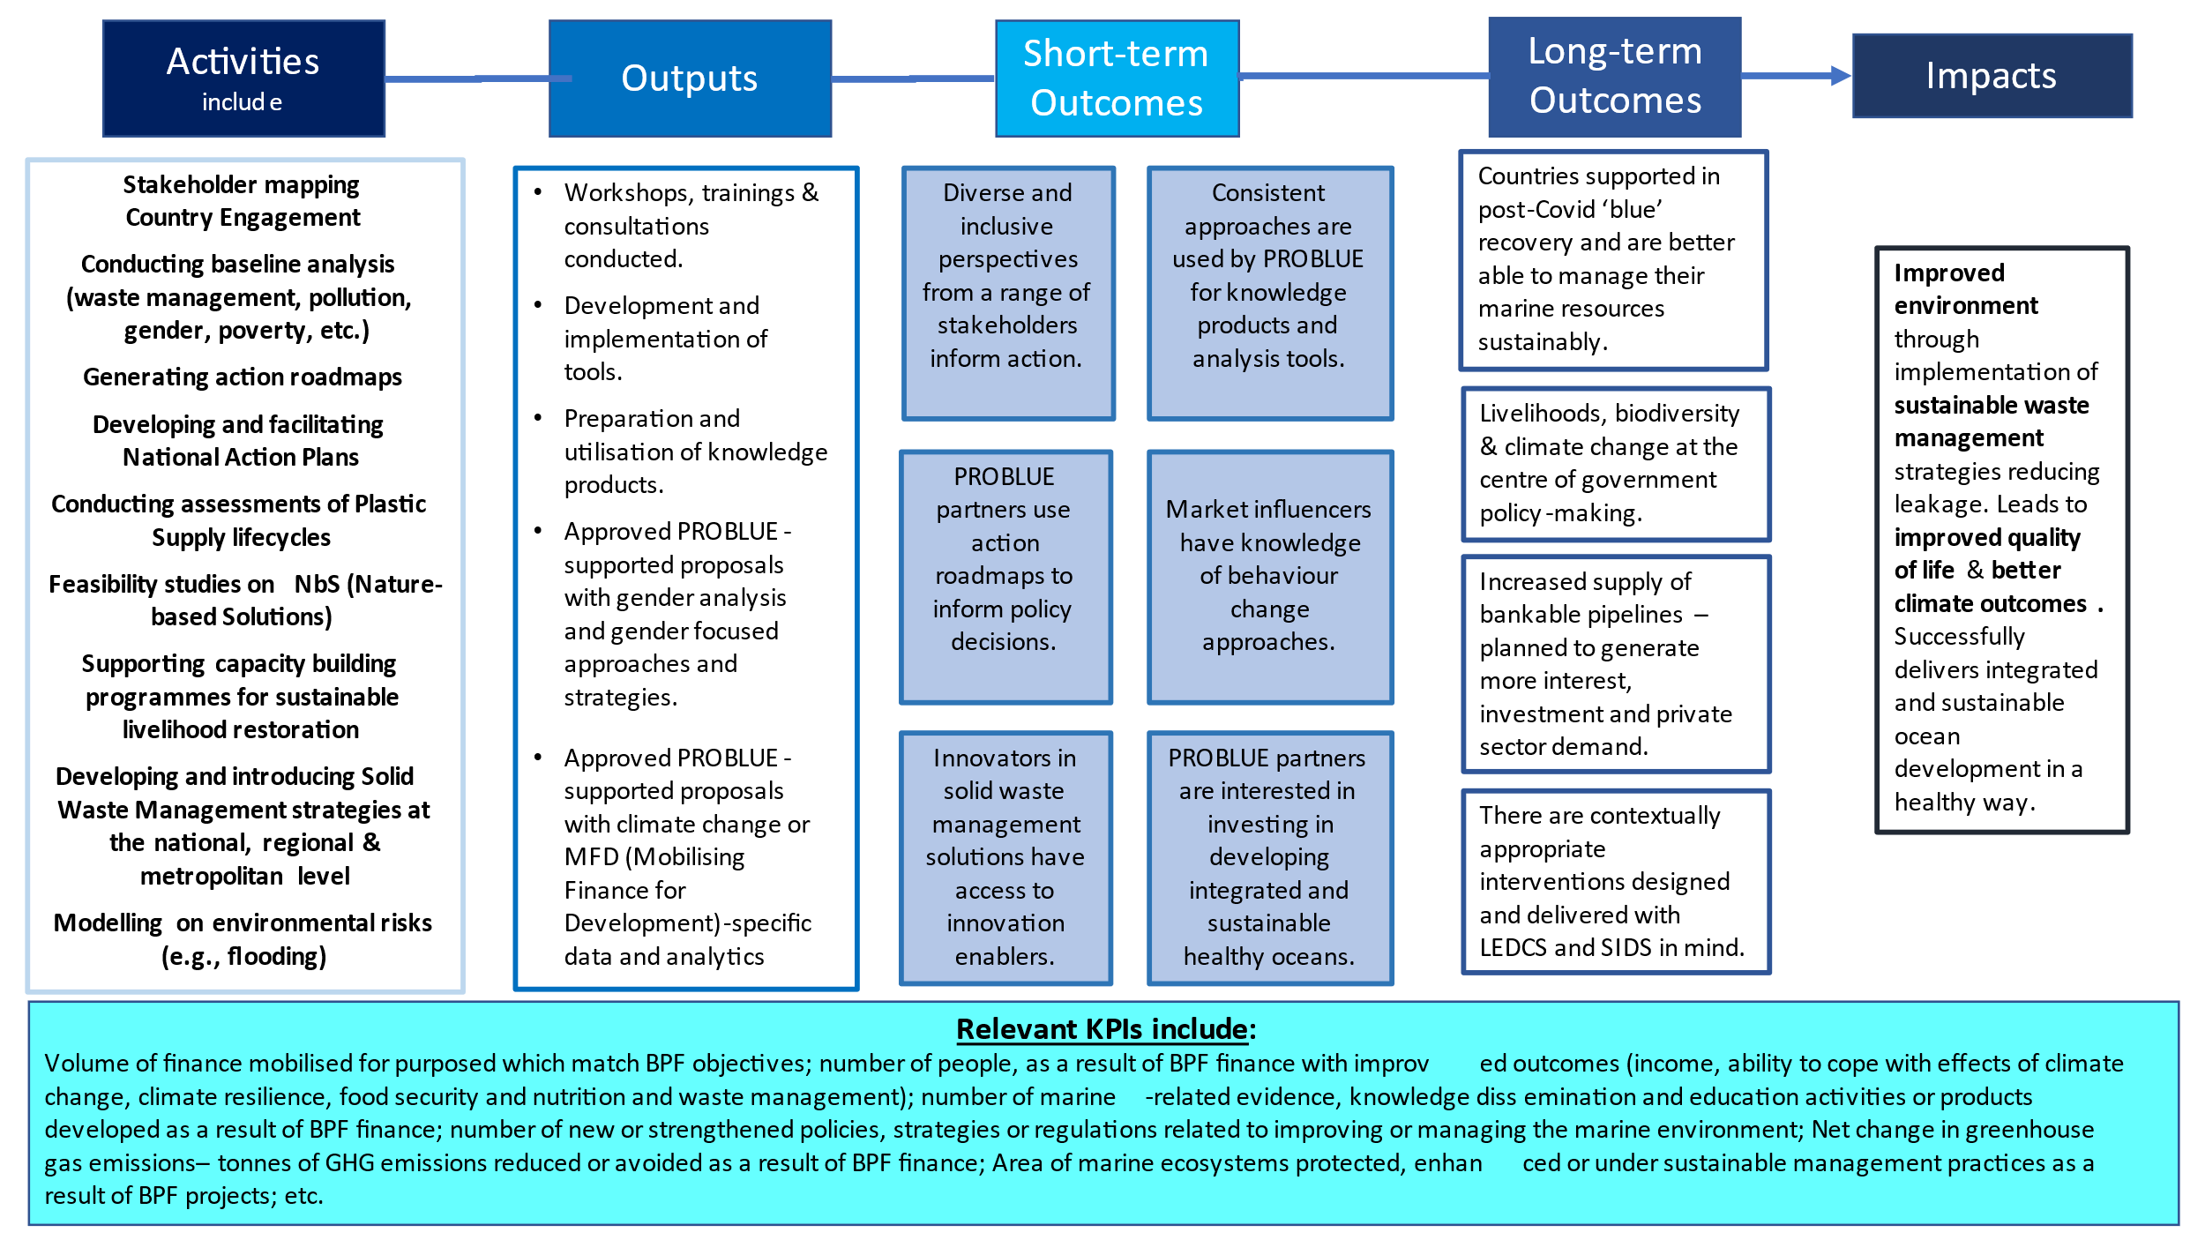

Annex 2b: PROBLUE Assumptions, risks and mitigations

Pathway | Assumptions | Risks | Mitigation
Overarching | The outcomes we have outlined are achievable in the timeframe. | We do not achieve these outcomes and achieve poor VfM. | Proper scoping of outcomes at the outset and keep them under review during the lifetime of the programme.
Overarching | The UK’s input into PROBLUE integrates well with other donor partners and recipients. | Disputes arise, slowing progress in achieving PROBLUE’s aims. | Maintaining sustained dialogue with PROBLUE colleagues and consistent flow of two-way communication. Being clear on priorities and promoting transparency in communication.
Overarching | Continued political will to implement action by in-country partners. | Country partners redirect resources to other priority areas, leading to reduced action and impact in tackling plastic pollution. | Close working with UK Post in High Commissions and embassies to demonstrate local support. Delegation visits from UK officials to maintain momentum and support work on the ground.
1 | The UK remains a trusted advisor to PROBLUE through maintaining strong relationships performing well in co-chair duties and practising good programme management. | The UK offers uninformed or unpopular advice, leading to reduced confidence in UK’s strategic direction. | Maintaining sustained dialogue with PROBLUE colleagues and consistent flow of two-way communication. Encouraging transparency in thinking.
2 | UK steer will enable good Value for Money as investment will be focused on UK priorities. | See above. | See above.
¾ | UK Ministerial support and UK leveraging power will help mobilise further donor funding. | The UK Minister wishes to stop supporting PROBLUE, the UK Minister changes, and new Minister is unsupportive. | Keeping the Minister briefed and supported on PROBLUE funding, activities and events and encouraging meaningful bilateral engagement with other ODA-donors. Demonstrating positive impact to the Minister.
5 | UK comments and input to country plans are taken forward and action plans are adopted. | The UK offers uninformed or unpopular advice, leading to reduced confidence in UK’s strategic direction.  PROBLUE overestimates in-country capacity to adopt and implement action plans. | Inputs to action plans are part of a collective effort across UK policy teams, ensuring expertise is captured and comments sense checked. Maintaining sustained dialogue with PROBLUE colleagues and consistent flow of two-way communication.  Ensuring we receive regular updates on progress across countries.
6/7 | PROBLUE and the UK share the necessary overarching values and objectives that support shared working. | One party will reject the ideas of the other, leading to disagreement and lack of strategic alignment. | Maintaining sustained dialogue with PROBLUE colleagues and consistent flow of two-way communication. Encouraging transparency in thinking.  Theory of Change, annual reviews and evaluations to hold delivery accountable to shared understanding of UK’s contribution to PROBLUE and track progress over time.
8 | Funding to PROBLUE will be spent on what is agreed between both parties, governed by conditions set out in the administration agreement. | PROBLUE spend the money on other activities without Defra’s agreement. | Fraud risk assessment in place to identify instances of fraudulent spend. Clauses in grant agreement set out accountability. Maintaining sustained dialogue with PROBLUE colleagues and consistent flow of two-way communication.
Table iv: Assumptions, risks and mitigations associated with section B2.1 ToC

Annex 2c: Key insights into progress through outcomes and outputs (Y1)

Indicator | Description | Progress FY19 | Progress FY20 | Progress FY21 | Progress F22 | End of programme targets FY26
Capacity building | Workshops, trainings, and consultations conducted (number) | 0 | 38 | 147 | 360 | 150
Tools | Tools developed (number) | 0 | 3 | 21 | 68 | 50
Knowledge products | Knowledge products prepared (number) | 0 | 0 | 80 | 236 | 100
Table i: The progress information in this table includes outputs of completed and ongoing activities.

Annex 3: Blue Planet Fund Theory of Change
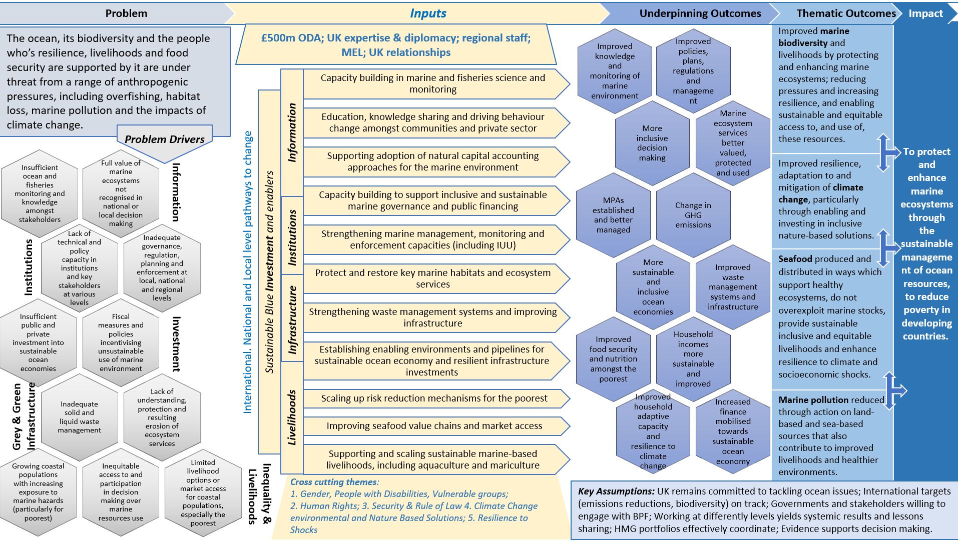

Annex 4: Output scoring

Label | Score
Outputs substantially exceeded expectation | A++
Outputs moderately exceeded expectation | A+
Outputs met expectation | A
Outputs moderately did not meet expectation | B
Outputs substantially did not meet expectation | C
Table v: outputs scoring

