UK PUBLIC HEALTH RAPID SUPPORT TEAM

Three-year strategic framework

2022 to 2025

“UK-PHRST appears to be the only full-time team dedicated to outbreak response with an explicit mandate to combine deployments with research and capacity building into a single offer in the GHS landscape. Across the board, the model is still seen as unique, pioneering and essential for influencing the outbreak research agenda globally and strengthening countries’ ability to respond quickly and effectively.” *

*Itad External review from critical informant interview

Contents

- EXECUTIVE SUMMARY 5
- STRATEGIC OBJECTIVES AND PRIORITIES 2022 to 2025 6
- BACKGROUND AND CONTEXT 7
Underpinning Principles 8
Partnerships 8
Government programmes 9
Academic partnerships 10
Impact 11
Learning 12
- THEORY OF CHANGE 13
- OUTBREAK RESPONSE 13
Background 13
Aims of the UK-PHRST deployment strategy 2022-2025 16
Improving Impact of Deployments 16
GOARN deployments 17
Bi-lateral deployments 17
UK-EMT deployments 18
UK-PHRST Capacity to Respond to Outbreaks 18
Core Deployable Teamn (CDT) 18
Reservists 18
Field Epidemiology Training Programme Fellows (FETP) 19
- RESEARCH 20
Background 20
Rationale for and approach to refreshing the research strategy 21
Aims and objectives of the UK-PHRST research strategy 2022-2025 22
Research strategy framework 23
Research gaps – evidence from stakeholder interviews and gap analyses 24
Capacity gaps for research 24
Evidence gaps 24
Research priorities 25
Strengthening UK-PHRST capacity to deliver research 26
Strengthening research capacity in ODA-eligible countries and fostering equitable partnerships – recommendations from stakeholder interviews 27
- CAPACITY DEVELOPMENT 28
Background and rationale 28
Capacity development gaps 29
Capacity development definition and scope 29
Conceptual framework 30
Capacity development offer 30
Training and education 32
- GOVERNANCE, GUIDANCE AND MANAGEMENT 33
Global Health Security Programme Board 33
UK-PHRST Project Board 34
Board composition 35
Technical Steering Committee 35
UK-PHRST Senior Management Team (SMT) 35
Ethics Committees 35
Project management 35
- REPORTING REQUIREMENTS 36
- RISK MANAGEMENT 37
Strategic risk 37
Operational risk 37
- MONITORING AND EVALUATION 37
Embedding monitoring, evaluation & learning 37
- EQUITY AND HUMAN RIGHTS 38
- FINANCIAL MANAGEMENT AND ACCOUNTING 39
Monitoring, reporting, and accounting of expenditures 39
Framework for priority setting and resource allocation 40
- LOGICAL AND RESULTS FRAMEWORK 40
- STAKEHOLDER ENGAGEMENT AND COMMUNICATIONS 41

Abbreviations and acronyms used in this document

AFRO WHO African Region Office
CDT Core Deployable Team
DHSC Department of Health and Social Care
FCDO Foreign and Commonwealth Development Office FETP Field Epidemiology Training Programme
GHS Global Health Security
GOARN Global Outbreak Alert and Response Network HMG Her Majesty’s Government
IHR International Health Regulations 2005
LMIC Low- and Middle-income Country
LSHTM London School of Hygiene and Tropical Medicine LSTM Liverpool School of Tropical Medicine
MEL Monitoring, Evaluation and Learning
MOU Memorandum of Understanding
MRC Medical Research Council
NIS National Infection Service
NIHR CCF National Institute for Health Research Central Commissioning Facility ODA Official Development Assistance
PB Project Board
PHE Public Health England
SRO Senior Responsible Owner
ToC Theory of Change
TSC Technical Steering Committee
UK-EMT UK Emergency Medical Team
UKHSA UK Health Security Agency
UK-PHRST United Kingdom Public Health Rapid Support Team VfM Value for Money
WHO World Health Organization

EXECUTIVE SUMMARY

Infectious disease outbreaks and epidemics continue to have a significant impact worldwide. The COVID-19 pandemic demonstrated the potential for rapid epidemic spread when an outbreak emerges. Countries across the globe now know that the impact of epidemics extend beyond loss of life and poor health, but also affect economic development, social order and national security. While leadership in outbreak preparedness and response in low- and middle-income countries (LMICs) is growing, much work needs to be done to strengthen global capabilities to respond to outbreaks more quickly and more effectively.
With a remit to support countries to control disease outbreaks that threaten public health before they can develop into global emergencies, the UK Public Health Rapid Support Team (UK-PHRST) was created in 2016 and is funded by UK aid from the Department of Health and Social Care. It is Jointly led by the UK Health Security Agency (UKHSA) - previously Public Health England (PHE) - and the London School of Hygiene and Tropical Medicine (LSHTM), this innovative partnership has an integrated triple-remit of outbreak response, research and capacity development to better enable the UK and international partners to respond to outbreaks of infectious diseases in LMICs.
The UK-PHRST model – an agile partnership between a world class national public health institute (UKHSA) and an internationally-renowned academic partner at the forefront of global health research (LSHTM) – is globally unique, widely respected and has greatly increased the speed and effectiveness of the UK’s response to global outbreaks. Between April 2017 and April 2022, the UK- PHRST has supported 26 outbreak responses, deploying 80 staff with 522 person-weeks in the field to date. The UK-PHRST has also undertaken 42 research projects supporting outbreak prevention and response across a range of geographies and disciplines. The UK-PHRST continued to support global partners throughout the COVID-19 pandemic, including providing remote and virtual support mechanisms for the first time.
Focusing on our three underpinning principles of partnerships, impact and learning, this Strategic Framework 2022 to 2025 sets out our objectives to build on the commitment, impact and effectiveness of the past 5 years of our operations. We have used our experience and learnings, together with systematic internal and external evaluations and evidence to develop the framework. Feedback from evaluations and our engagement with UK and international partners highlighted the need for flexibility and responsiveness in the support that is offered.
In order to deliver our strategic objectives across the next three years, our staffing capacity will be scaled up to maximise the impact of our outbreak response, build resilience and enable a more ambitious research and capacity development agenda.

Dr Ben Gannon
Interim Director, UK-PHRST May, 2022

STRATEGIC OBJECTIVES AND PRIORITIES 2022 to 2025

The UK-PHRST OBJECTIVES for 2022 to 2025 define the triple mandate across outbreak response, research and capacity development:
  - supporting partners in LMICs to prepare for, prevent, detect and respond rapidly to disease outbreaks, with the aim of stopping a public health threat from becoming a health emergency

  - identify research questions with partners and deliver rigorous research with partners that improves the evidence base for best practice in disease outbreak response in LMICs

  - supporting the development of in-country capacity for an improved and rapid national response to prepare for, prevent, detect and respond to disease outbreaks

This strategic framework has been developed as a foundation for UK-PHRST's remit with the following PRIORITIES set to deliver the 3 objectives:

OBJECTIVE 1 PRIORITIES: Outbreak response
    - improve impact of deployments
      - review and improve deployment models
      - support more frequent and simultaneous operational deployments
      - facilitate the increased use of the bilateral deployment mechanism
    - provide deployable capacity which is fit for purpose to support international outbreak responses in LMICs through the provision of technical expertise

OBJECTIVE 2 PRIORITIES: Research
    - create a more ambitious, long-term research programme structured into themes aligning with DHSC’s Global Health Security Programme Theory of Change outcomes
    - foster greater co-creation and LMIC partner leadership in research delivery
    - prioritise research according to partner needs and gaps in evidence that focuses on informing better outbreak response capability.
    - prioritise operational research complemented by a parallel programme of scheduled multi-disciplinary research
    - prioritise approaches that support the uptake of research evidence into policy decisions and best practice including the addition of implementation science capacity

OBJECTIVE 3 PRIORITIES: Capacity development
    - establish a capacity development, training and education pillar including dedicated public heath consultants and support staff leading strategic direction and enabling delivery of sustainable, impactful capacity development projects with LMIC partners that focus on response capabilities
    - build and maintain UK-PHRST's partnership base by working closely with LMIC institutions that are demonstrating leadership and using existing networks to expand collaborations in other outbreak-prone countries and regions
    - define the operational environment of capacity development through the introduction of a conceptual framework
    - provision of a framework to develop capacity development across the remits

CROSS-PROGRAMME PRIORITIES

    - resource and embed monitoring, evaluation and learning across the programme through the introduction of new processes, tools and assessments. This will ensure long term sustainable impact from activities across the triple remit
    - resource and embed equity and Human Rights across the programme through the introduction of new processes, tools and assessments. All UK-PHRST activities will be evaluated in terms of their impact on equity and human rights
    - build a robust governance process to ensure accountability, quality and timeliness of activities across the triple remit, prioritising partner needs
    - strengthen human resourcing increasing depth and breadth of expertise to deliver a more ambitious and resilient programme develop hybrid and remote operating modalities to increase programme efficiency

BACKGROUND AND CONTEXT

The RST was established by the DHSC in response to the lessons of the West African Ebola outbreak. It is a partnership between PHE (now UKHSA) and LSHTM and funded through DHSC ODA. The team supports delivery of UK and global policies to protect the public’s health and strengthen global response efforts aligning with a number of DHSC and HMG commitments including SDGs, integrated review and international development and global health strategies.
Launched in 2016, the UK-PHRST has a unique approach, combining outbreak response, operational research to generate evidence on best practices for outbreak control, and capacity building for outbreak response in ODA-eligible countries. While leadership in outbreak preparedness and response in LMICs is growing, e.g. through Africa CDC and similar institutions, as the COVID-19 pandemic has demonstrated, there remains considerably more work to be done to strengthen global response capabilities. The UK-PHRST model remains an effective way to deliver the triple mandate of outbreak response, research and capacity development¹, as the two organisations are able to draw from significant expertise and experience in operational response and research in infectious disease outbreaks. The team is multi-disciplinary and comprised of experts in public health, epidemiology, microbiology, infection prevention and control (IPC), social science, mental health, training and education, and knowledge management, supported by a core management team.
Capacity development activities have been embedded in the programme from the outset, during deployments and research projects and by delivering standalone projects, for example, in workforce development and academic and/or online courses targeting project partners and LMICs generally.
The UK-PHRST is now recognised as a leading international outbreak deployment team and with increased funding, the UK-PHRST can build substantially on the previous successes by structuring the project to incorporate the learning from previous actions and evaluation exercises, expand our partnerships and networks, and increase the impact and effectiveness of the programme.

1 “There is broad agreement that the consortium model adds value towards improving outbreak response through bringing together complementary expertise, experiences and partnerships”. Itad end point evaluation 28/04/21 https://www.itad.com/wp- content/uploads/2021/09/UK-PHRST_End-point_Evaluation_Myd2Qts.pdf

Underpinning Principles

The strategy is underpinned by three principles: learning, partnerships and impact. These principles overlap and interact to provide a framework for development.

Figure 1: Underpinning Principles

Impact

Partnerships

Learning

Partnerships

Developing and strengthening partnerships means the UK-PHRST can respond rapidly when and where needed. Working with the UK government, WHO and GOARN, we have created a global network that influences and shapes policy to frame more effective outbreak responses of the future. Our partnerships with LMICs are the most critical, tackling disease outbreaks at the frontline and working together to be better prepared for the next epidemic.
Regional and national partners will continue to share their expertise, knowledge, and cultural insights. The bringing together of ideas, expertise and experiences can create a shared vision and mutual goals to improve responses, research, and capacity development that are aligned more closely to local needs in LMICs. Routinely integrating co-creation and co-delivery into UK-PHRST projects also improves their impact and effectiveness, enables UK-PHRST to establish more equitable partnerships and supports the decolonising global health agenda in LMICs.
A critical element for the UK-PHRST strategy for 2022-25 is the expansion of our partnerships and networks to better facilitate the sharing and application of local improvements, lessons learned and research evidence with regional and global networks and vice versa. A tool for prioritising partnerships has been developed and will be used as a prompt for reflection and discussion when considering developing new partnerships or reactivating previous partnerships. To maximise impact and reach, partnerships will be prioritised based on certain criteria pertaining to alignment (mission, priorities and technical areas), impact (including needs, assets, influence, scale, connection/networks, equity and sustainability), and risk (including security, stability, conflict of interest, capacity and financial).
Broader networks and development of communities of practice will support coordinated actions from multiple stakeholders and increase sustainability and impact. The UK-PHRST will build global north-south and south-south collaborations and support mechanisms. This will strengthen UK- PHRST's global positioning and enable more bilateral deployments and expanded capacity development and research programmes.
Partnerships fostering mutual participation, trust, respect, and benefit will be the cornerstone of UK- PHRST's programme of work, improving our outcomes and impact and building resilience to operate more effectively in challenging environments.

Government programmes

The UK-PHRST is an integral part of the UK government’s response to global health security, contributing to the strategic objectives of prevention, detection and early response to global health threats. As part of a coordinated, cross-government response, the UK-PHRST sits alongside other endeavours² as part of a comprehensive programme of investments aimed at increasing Global Health Security. The UK-PHRST will work closely with all these partners and projects to ensure that our work is aligned across the broader UK HMG GHS, health system strengthening and research endeavours, coordinating our efforts to assure continuity of our outbreak-focused work with the

2 Including the Fleming Fund, the Global AMR Innovation Fund (GAMRIF), international AMR policy, the UK Vaccine Network, the IHR Strengthening Project (DHSC funded, delivered by the UKHSA), FCDO successor to Tackling Deadly Diseases in Africa Programme and the UK-EMT.

capacity building goals of the broader UK initiative. Through these collaborations, we will form links, create synergy and maximise impact.
A key interaction will be with UKHSA’s Global Operations, in particular with the International Health Regulations Strengthening Project that works with many of the same countries and regions as the UK-PHRST (specifically, Zambia, Nigeria, Ethiopia). The ultimate goal of both projects is to develop and support health system capacity in LMICs. While UK-PHRST focuses on the capacity to prevent and respond rapidly to health emergencies, we recognize that such capacity is ultimately dependent on a broader base of health infrastructure and trained personnel in LMICs. The UK-PHRST will assure continuity of our outbreak-focused work with UKHSA IHR capacity building goals, providing a link between the immediate response to a crisis and the longer-term actions needed to strengthen systems to minimise future risk.

Academic partnerships

The UK-PHRST will seek to leverage and contribute to the many established projects of its academic partners. Of particular interest are the Medical Research Council units in the Gambia and Uganda that have been units within LSHTM since February 2018. In addition, University of Oxford has permanent tropical infectious diseases research centres in various sites, including Kenya, Thailand, Vietnam, Nepal, Laos, and Myanmar.

Impact

A focus over the next three years is ensuring our actions have long-term, sustainable impact, and that sustainable ways of working are embedded in our approach across our triple mandate of outbreak response, research and capacity development. The UK-PHRST Sustainability Working Group will implement a sustainability plan to ensure actions will have better impact across the programme. Overarching sustainability objectives include delivering value for money, mitigating the environmental impact of the UK-PHRST programme and adapting activities where possible, taking a One Health approach to deliver activities that strengthen our own and our partners’ response to climate change and infectious disease threats, and raising awareness on social equity issues (e.g. gender and racial issues) across our partnerships, internally and externally, in delivery of our activities. To ensure sustainable outcomes across the triple remit, activities will include (but are not limited to): investing in outbreak preparedness activities, linking deployments to mid to longer-term planning with partner countries where feasible, undertaking research that strengthens national/regional health systems around outbreak preparedness and response, and engaging wider national and regional stakeholders in the delivery of workshops, training courses or other capacity development activities.
To further maximise our impact, we will ensure our actions are tailored to partner needs. Across the triple mandate we have incorporated an operational (emergency) workstream to facilitate flexible, rapid action and generate insight during or in the wake of deployments, and a scheduled programme allowing longer term and directed action to provide evidence and develop capacity where there are pre-determined priorities. For example, our research will address critical questions that improve response effectiveness and are co-developed with partners – this is being achieved by systematically appraising gaps and opportunities through an evidence gap analysis, stakeholder interviews, feedback from external evaluations by Itad and After Action Reviews. The team will be strengthened by the addition of implementation science experts to evaluate dissemination and uptake of evidence into policy decisions and best practice.
Mechanisms for evaluating impact will be agreed at the outset of activities across the remit. A monitoring, evaluation and learning (MEL) plan will be included in the design and development phase of new activities to ensure that appropriate and effective systems are in place to measure impact. We will develop guidance outlining the under-pinning principles and recommended approaches for strengthening equity and human rights (EHR). We will expand our network of partners to increase the scope and reach of our work.
These efforts, together with the significant learning we have gained over the past five years including use of hybrid delivery mechanisms during the pandemic, will ensure that our actions over the next three years are more sustainable and have greater impact.

Learning

Since UK-PHRST's inception, significant lessons have been learnt about ways of working, process development and critical elements for successful delivery. Recent epidemics have also shown the interconnected nature of the health of animals, humans and the environment and a One Health approach must be promoted to prepare for and respond to future threats more effectively. A culture of ongoing learning is needed to ensure the programme impact is maintained and continually improves. Internal processes, evaluations and external reviews have captured key lessons and continue to inform process development. An external end-point programme evaluation from Itad highlighted six key areas to strengthen and this along with internally commissioned reports on research gaps and stakeholder opinions have informed the development of this strategy.
The Itad external end-point programme evaluation recommendations were:
- Ensure sufficient capacity to adequately meet the demands of programme delivery and maximise successful outcomes across the triple mandate, by advancing recruitment plans, using reservists and FETPs where possible, and clearly articulating a request for more human resources in any future phase
- Deepen in-country networks and partnerships to achieve programme objectives (particularly in relation to sustainability) through an updated approach to partnerships.
- Put greater emphasis on ensuring that research is used to inform decision making and to guide policy in LMICs, by articulating and implementing a research uptake strategy and further aligning research questions with needs
- Further define and embed UK- ’s scope of work and ways of working, especially within capacity development, and improve partners’ awareness and understanding of UK- ’s mandate through an effective communications plan
- Continue to strengthen and implement UK- ’s approach to maximise chances to contribute to desired outcome level results and to be able to demonstrate contribution at this level.
- Retain lessons learned during COVID-19 through a ‘blended’ approach combining in person and remote support

THEORY OF CHANGE
The UK-PHRST Theory of Change (ToC) is shown in figure 2. The intended long-term impact of the project is for the global population, including the UK, to be safer and more secure from global health security threats.

Figure 2. UK-PHRST Theory of Change³
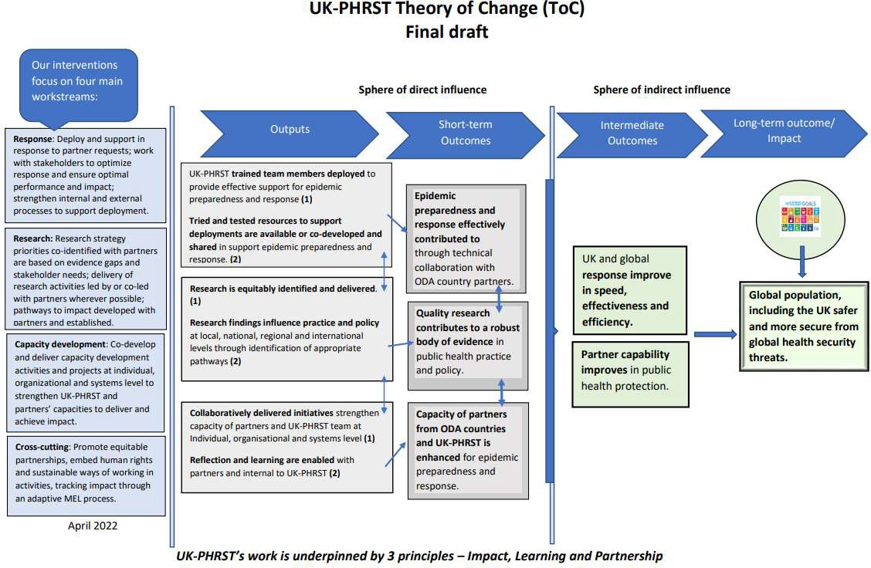

OUTBREAK RESPONSE

Background
The UK-PHRST will maintain the capacity to be ready to deploy to ODA-eligible countries within 48 hours’ notice of HMG authorisation where required. Rapid public health responses have the potential to quickly control or even prevent outbreaks. To respond rapidly and effectively to outbreaks the UK-PHRST provides a cadre of trained and skilled experts available for deployment (including reservists, FETP Fellows and other affiliated personnel and trainees).⁴ Requests for deployments are evaluated and prioritised in terms of risk and impact, taking into account:
  - ODA-eligibility of the country in question
  - the potential scale of the event in terms of case counts, excess morbidity and mortality; risk of spread locally, regionally and internationally; and ancillary factors such as potential economic impact or potential to produce civil unrest and insecurity

4 These personnel are a prerequisite for all UK-PHRST activities in outbreak response, research and capacity building overseas, and thus feed into all three intermediate and long-term UK-PHRST outcomes.

  - UK-PHRST’s capacity to fill the gaps in technical expertise and human resources through the CDT, reservists, FETP Fellows and affiliated personnel
Deployments may be through participation in international teams, WHO/GOARN, bilateral agreements with other governments or in support of other UK actors, such as FCDO and UK-EMT. The UK-PHRST will continue to seek to arrive early in the field, providing rapid context analysis, risk assessment of developing threats and feedback to Ministries of Health, HMG, UK-Med, WHO/GOARN, and other local and international stakeholders regarding transmission dynamics and required steps and capacities to stem transmission and optimise patient care. The UK-PHRST contributes services such as enhanced epidemiologic surveillance and analysis, information management, and technical guidance on public health control measures, laboratory diagnosis, infection prevention and control and social science, including risk communication and community engagement.
To date UK-PHRST has predominately worked through GOARN. Operating through WHO enables UK- PHRST to place technical experts into the epidemic response structure in country through the established WHO links with the government public health and response functions.
UK-PHRST deployments to date are presented in Figure 3.

Figure 3: UK-PHRST deployments April 2017- April 2022

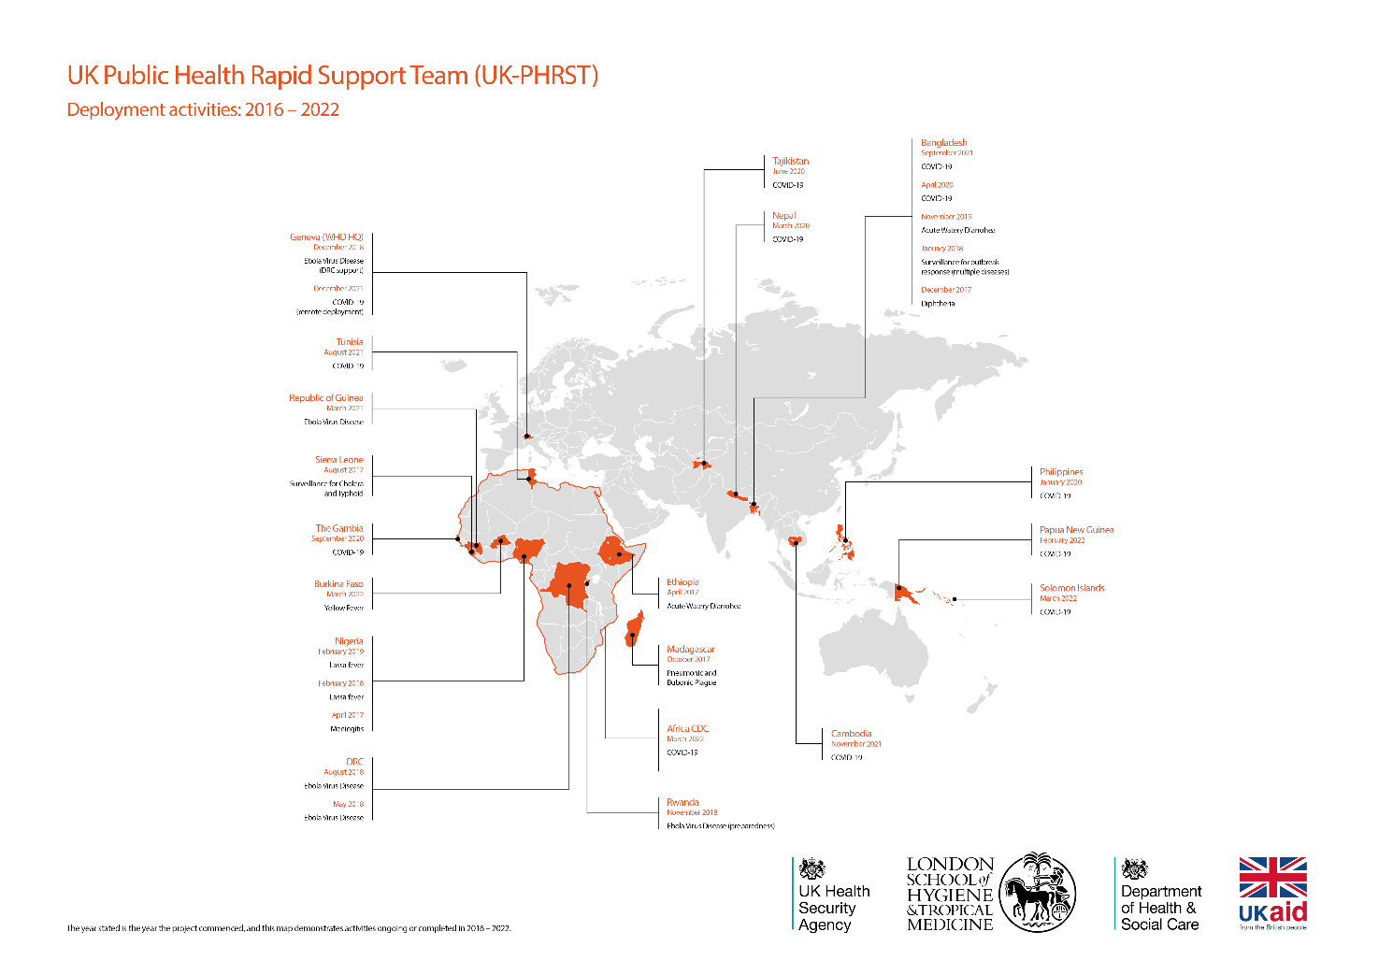

Figure 4: UK-PHRST Outbreak Response Deployment Strategy 2022-2025

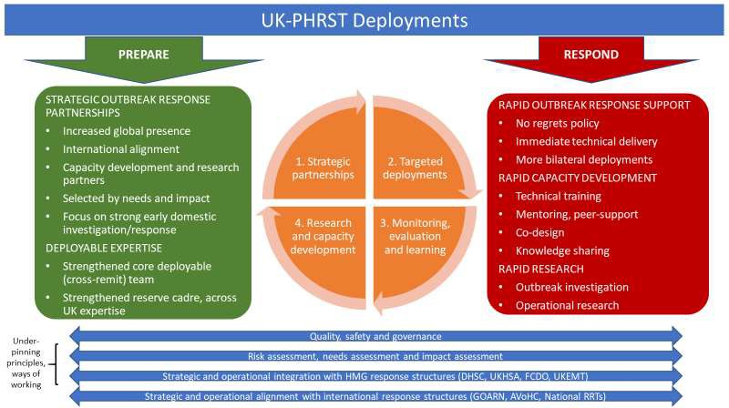

Aims of the UK-PHRST deployment strategy 2022-2025
The UK-PHRST Outbreak Response Deployment Strategy 2022-2025 is shown in Figure 4. The overall aims of the strategy are to:
  - improve the IMPACT of deployments, including to
    - review and improve deployment models
    - support more frequent and simultaneous operational deployments
    - facilitate the increased use of the bilateral deployment mechanism
  - provide DEPLOYABLE CAPACITY which is fit for purpose to support international outbreak responses across the globe through the provision of technical expertise

Improving Impact of Deployments
We will continue to evolve how we operate to increase impact through the continuous learning philosophy applied across the programme through the MEL programme.
It is useful to consider deployments in the context of the underpinning principles of partnerships, impact and learning. Developing and establishing partnerships is essential for deployments to have an impact. We have learnt through the experience from the past 5 years of operations several key challenges to enable more impactful working. COVID-19 created many travel limitations reducing the capability to respond to outbreaks. The use of innovative, remote support mechanisms has been offered to partners with all indicating that in person deployment is essential. However, as networks improve and online working becomes more accepted, remote operating models will begin to become more prevalent. The utility, uptake and effectiveness of this way of working will be further assessed across all of the deployment mechanisms. Initial conclusions from deployments indicate that remote deployments are not appropriate in many cases. In person deployments are more

effective at building trust and developing relationships with partners and enable the team to witness, understand and resolve daily challenges in the field. However, there remain opportunities to use this mechanism or a hybrid model combining in person and remote either in parallel or consecutively to provide an efficient way to deliver support. Further innovative methods will be explored to strengthen our response offer and improve effectiveness.

GOARN deployments

Significant learning points from previous GOARN deployments include:
  - operating via GOARN allows rapid placement of the technical experts to infectious disease outbreaks
  - operating through GOARN allows UK-PHRST to benefit from established WHO relationships as UK-PHRST operates through WHO
  - GOARN deployments provide significant operational and logistical support from WHO reducing resource and risk burden on UK-PHRST
  - operating through WHO as an intermediary result in an indirect relationship with the receiving government and public health officials
There are significant benefits of working with GOARN as listed in the learning points. Working via an intermediary presents challenges for effective action, especially when setting mission parameters, the terms of reference (ToRs), deployment length and expertise provided.
Mission parameters are initially set by WHO for GOARN deployments. This brings a degree of inflexibility to tailor the response to match needs due to the use of generic ToRS, often used to expediate deployment so action is swift. However, parameters such as deployment length, type of technical expertise deployed and specific outputs of the objectives would enable more effective responses and impact. UK-PHRST will seek to adapt the model used by GOARN for deployments to consider these elements and promote the use of bilateral deployments where a more customised approach can be applied.

Bi-lateral deployments
The ability for UK-PHRST to set the parameters of the deployment missions is increased with bilateral deployments due to direct agreement of mission objectives and programmes of work with the receiving government, as opposed to GOARN deployments where GOARN and WHO are intermediaries.
UK-PHRST will promote the use of bilateral deployments by:
- developing new partnerships through capacity development exercises, targeting actors through stakeholder analyses and aligned to strategic aims of:
  - broader global coverage including Indo-pacific, European and Middle East and South American regions whilst maintaining and building on African partnerships
  - greater impact of work through collaborations with recognised global programmes and public health institutes, organisations and networks
- Increasing engagement with UK programmes to benefit from established relationships, adding value to the UK offer: DHSC GHS programmes, FCDO health advisor network, UK academic overseas links (eg MRC units, Oxford Mahidol)

UK-EMT deployments
The co-deployment of UK Emergency Medical Team (EMT) and UK-PHRST has been advocated where synergy is identified on public health action. This model will continue to be supported, facilitated through regular meetings between these projects and agreed ways of working to allow efficient activation. This mechanism has resulted in three joint deployments between April 2017 and April 2022.

UK-PHRST Capacity to Respond to Outbreaks
The UK-PHRST is a collaboration between the UK’s health protection agency and academia. Although we will take advantage of the historical strengths of the partner institutions (e.g. public health response at UKHSA and teaching and research at LSHTM), the UK-PHRST will function as a single cohesive group with unity of purpose. All core deployable team (CDT) members will engage in outbreak response, research, and capacity building endeavours.
Despite the growing global health workforce and significant gains in human resource that have been made during the COVID-19 pandemic, the number of requests for assistance from GOARN continues to grow. This, in combination with increased demand in the portfolio of capacity development, research projects and partner engagements proposed in this strategic framework will place a higher demand on UK-PHRST technical and operational support capacity. The next phase of UK-PHRST will increase the size of core deployable team, operational support staff (across the triple mandate), continue to provide opportunity for FETP trainees to deploy and increase the reservist pool.

Core Deployable Teamn (CDT)
The CDT (n=11) for the UK-PHRST currently consists of the following:
  - Epidemiologists, including data science (6)
  - Public Health Microbiologists (2)
  - Social Scientist (1)
  - Infection Prevention and Control Specialists (2)
The CDT team will be increased (n=17) to provide strength in depth and breadth of expertise. An analysis of GOARN requests over the past 3 years has highlighted the need for experts in risk communications and community engagement which have been added to the team.
  - Epidemiologists, including data science (7)
  - Public Health Microbiologists (3)
  - Genomics expert (1)
  - Social science (1) and Risk Communication and Community Engagement (2)
  - Infection Prevention and Control Specialists with case management expertise (3)

Reservists
Alongside the growing CDT, there is an increasing requirement to enhance and build the existing reserve cadre to support the UK-PHRST remit. Reservists complement the CDT by providing surge support and additional expertise for deployment requests. They are able to be deployed alongside specialists from the CDT as part of a team and also independently at a senior level.

They are also able to provide expertise to a wider range of UK-PHRST activities (beyond operational deployments) and have effectively done so during 2021. The UK-PHRST plans to harness this broader input provided by reservists and embed robust processes to enable them to support capacity development, training and in some cases research activities.
UK-PHRST plan to strengthen the existing skill sets through additional recruitment drives for reservists. There will be an immediate focus in 2022 to expand the number of reservists in Epidemiology, Infection Prevention and Control and Public Health Microbiology as this need has been identified as critical to ensure a robust deployee roster. We plan to work closely with and engage support from key representatives within the institutions of the UK’s devolved administrations to ensure reservists are a truly UK wide asset. Advertisements and opportunities will be through a fair, open and competitive process. As previously, essential skills such as language and diplomatic relations aptitude will be critical to ensure a strong calibre of staff is able to represent UK-PHRST.
A workforce review process to identify additional skills not currently present in the CDT will take place in Q2 2022 with the aim of recruiting expertise not immediately available to RST. This will further expand the ability of the team to provide a wealth of public health support, broadening our capacity and capability to respond to requests for assistance.
Having developed a successful model of recruitment, reservists external to the UK-PHRST will continue to be employed on bank contracts which allows home departments to save their salary whilst they are overseas. This enables them to be released at no cost to their home team and allow backfilling as appropriate.

Field Epidemiology Training Programme Fellows (FETP)
Developing a cadre of future epidemiologists with the skills and experience to respond to outbreaks in LMICs is essential to controlling outbreaks both overseas and limiting risk of transmission and spread in the UK. Toward this goal, the UK-PHRST will continue to offer opportunities to UK FETP fellows to work in UK-PHRST deployments and projects.
Each year, the UK-PHRST will provide opportunities for five to six FETP fellows to actively contribute to a wide range of UK-PHRST activities across the remit. Individuals will be selected through an Expression of Interest process. All selected fellows will undergo the same deployment training and medical clearance as the CDT. Once graduated, fellows will be encouraged to remain on the UK- PHRST Reserve Cadre to continue their support and widen their experience of responding to and supporting global partners in outbreaks.

RESEARCH

Background
UK-PHRST has been unique in establishing a multi-disciplinary research programme that is integrated within outbreak operations and which has robust research governance procedures. Over the past six years UK-PHRST has conducted rigorous and often high-profile research to support and improve outbreak preparedness and response.
UK-PHRST’s research strategy has evolved over time but has continued to be multi-disciplinary and address key priorities that have been identified by and increasingly co-developed with LMIC partners and provide evidence to improve practice to prepare, prevent, detect and respond to outbreaks. It has had two main components including:
  - research ‘in the field’ conducted during or in the wake of outbreaks (responsive research), often during UK-PHRST emergency response deployments, and
  - research that improves preparedness to respond better to future outbreaks, categorised into five research themes or disciplines:
    - epidemiology and population sciences
    - patient-centred research
    - microbiology and laboratory sciences
    - social science and community engagement
    - mental health and wellbeing
More recently, these five themes have been complemented by research in IPC, public health and education disciplines.
UK-PHRST research projects have developed from outbreak deployments, preparedness assessments, direct country requests, capacity-development collaborations, and collegial networks and to date, UK-PHRST has completed 30 research projects and a further 12 are ongoing (Figure 5. Research map). These have been diverse and spread across the theme disciplines, many multi- disciplinary [5]. Recent examples include an investigation of lessons learned from previous mass outbreak-related vaccination campaigns in low resource settings leading to recommendations for COVID-19 vaccine roll-out across LMICs[6]; a cohort study highlighting the severity, impact and genetic origin of Chikungunya virus outbreaks[7]; and field assessments of novel assays to identify

- [Raftery P, Hossain M, Palmer J. An innovative and integrated model for global outbreak response and research - a case study of the UK Public Health Rapid Support Team (UK-PHRST). BMC Public Health. 2021;21(1):1378.

- Collins J, Westerveld R, Nelson KA, Rohan H, Bower H, Lazenby S, Ikilezi G, Bartlein R, Bausch DG, Kennedy DS. 'Learn from the lessons and don't forget them': identifying transferable lessons for COVID-19 from meningitis A, yellow fever and Ebola virus disease vaccination campaigns. BMJ Glob Health. 2021 Sep;6(9):e006951
- Bower H, El Karsany M, Adam AAAH, Idriss MI, Alzain MA, Alfakiyousif MEA, Mohamed R, Mahmoud I, Albadri O, Mahmoud SAA, Abdalla OI, Eldigail M, Elagib N, Arnold U, Gutierrez B, Pybus OG, Carter DP, Pullan ST, Jacob ST, Abdallah TM, Gannon B, Fletcher TE. "Kankasha" in Kassala: A prospective observational cohort study of the clinical characteristics, epidemiology, genetic origin, and chronic impact of the 2018 epidemic of Chikungunya virus infection in Kassala, Sudan. PLoS Negl Trop Dis. 2021 Apr 30;15(4):e0009387.

previous Ebola and Lassa Fever virus infections that might help countries target resources for surveillance, preparedness and response[8].
Over the course of activities, UK-PHRST has developed substantial expertise in qualitative and quantitative research methodologies (including study design, protocol development and analysis), implementing and evaluating research in the field, and translating research evidence to inform policy and public health practice. Research delivery and partnership working have also evolved, including broadening research collaborations in LMICs and academic partners in the UK. However, despite this and in parallel with UK-PHRST deployments, the majority of research projects have been in the Africa region, with a small number in South East Asia and none in Central and South America.

Figure 5. UK-PHRST Research Projects, 2018 to 2021

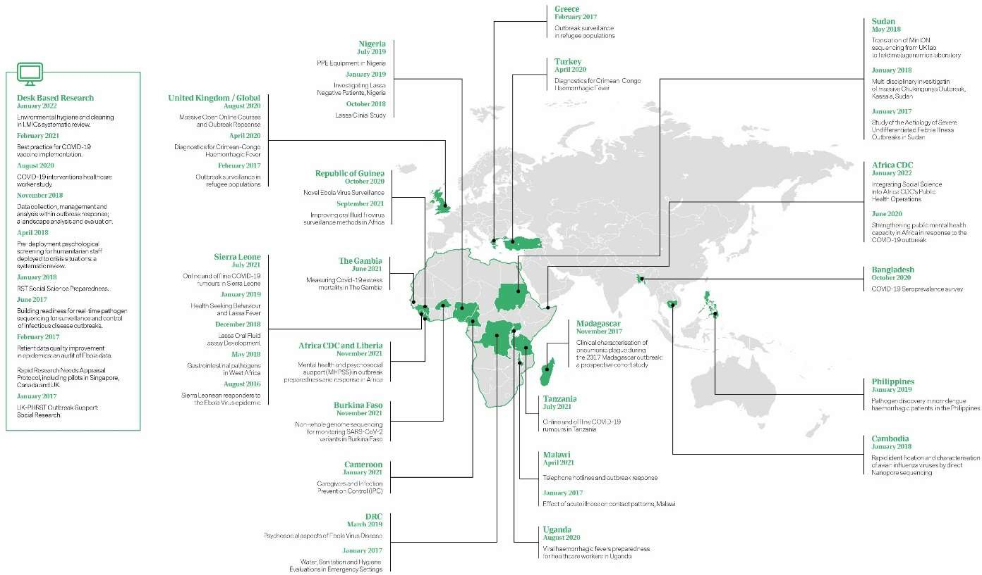

Rationale for and approach to refreshing the research strategy
It is important to review and refresh UK-PHRST’s research strategy in preparation for the next phase of the programme to ensure it remains fit for purpose. Since the programme’s inception, there have been significant contextual shifts that have influenced decisions on research priorities, who identifies them and how they should be delivered. These include growing recognition of the need to decolonise global public health[9]] and the global COVID-19 pandemic. Recent formal and informal

- Akpogheneta O, Dicks S, Grant D, Kanneh Z, Jusu B, Edem-Hotah J, Kanneh L, Alhasan F, Gbakie M, Schieffelin J, Ijaz S, Tedder R, Bower H. Boosting understanding of Lassa Fever virus epidemiology: Field testing a novel assay to identify past Lassa Fever virus infection in blood and oral fluids of survivors and unexposed controls in Sierra Leone. PLoS Negl Trop Dis. 2021 Mar 31;15(3):e0009255.

- Khan M, Abimbola S, Aloudat T, et al Decolonising global health in 2021: a roadmap to move from rhetoric to reform BMJ Global Health 2021;6:e005604.

reviews of UK-PHRST’s research activities, described below, have made recommendations that address many of these issues.
An After-Action Review (AAR) of the UK-PHRST in January 2021, including key LMIC partners and Itad, emphasised the importance and value of co-ownership and co-creation with LMIC partners, including the need to identify ways to enable LMIC partners to lead research, increase community engagement and representation, strengthen dissemination of research findings and best practice, improve monitoring of research uptake in policy and practice, create new partnerships to harness opportunities and better measure and reflect the contribution of partners. Furthermore, feedback from DHSC and NIHR highlighted the need to have a clearer rationale for the engagement of project partners and develop a more coherent strategy for prioritising research, including the need for an overarching longer-term research framework.
Additionally, an external review of the UK-PHRST by Itad highlighted strategic areas for strengthening and made several recommendations that were especially relevant to the research remit[10]. These included the need for a research dissemination and uptake strategy to ensure “research is used to inform decision making and to guide policies in LMICs” and for research questions that have a stronger link with response needs. ITAD also recommended that UK-PHRST further strengthen and implement monitoring, evaluation and learning to better deliver and demonstrate desired outcomes and to embed gender equality, equity and human rights across the remits.
UK-PHRST learned to adapt its research support offer during the COVID-19 pandemic, including development of remote project supervision and training packages, and shipping kits and equipment direct to research sites. To some extent COVID-19 restrictions have strengthened co-creation and co- working models by encouraging in-country collaborators to engage with, lead and deliver research. However, remote working is not conducive to detailed discussion between partners of complex ideas and resolution of issues, often a crucial component of project development, which has occasionally hampered engagement. Despite this, UK-PHRST recognises there is value in continuing to develop virtual and mixed support mechanisms including micro-mentoring approaches, remote supervision and training packages. There is also recognition that UK-PHRST can make greater use of its unique format and agility to broaden the geographical scope of UK-PHRST research interests into other outbreak-prone global regions.
Consequently, UK-PHRST has revised and redeveloped the UK-PHRST Research Strategy for 2022-25. It has been shaped by feedback from the AAR, ITAD, DHSC and NIHR and experience gained by the UK-PHRST since the programme’s inception. The revised strategy builds on the research approach over the past six years to ensure coherence, and that it is driven by LMIC needs and priorities. It aims to make research prioritisation more transparent to UK-PHRST stakeholders.

Aims and objectives of the UK-PHRST research strategy 2022-2025
The aim of the UK-PHRST research strategy is to deliver a coherent, structured, partner-led research programme informed by public health need. Its specific objectives are to:
- create a research framework comprising rapid and responsive operational research complemented by a parallel programme of scheduled multi-disciplinary research, aligned with Global Health Security Theory Change outcomes

- Itad. End-point evaluation of the UK Public Health Rapid Support Team (UK-PHRST) – final report. 21st September 2021. (https://www.itad.com/knowledge-product/end-point-evaluation-of-the-uk-public-health-rapid-support-team-uk-phrst- final-report)

- identify and prioritise research activities according to partner needs and gaps in evidence
- foster genuine co-creation and LMIC partner leadership in research delivery
- prioritise research dissemination and develop pathways to impact that improve public health practice in outbreak preparedness and response

Research strategy framework
As previously, the two major components of the research strategy will include:
- operational research arising during or in response to UK-PHRST’s deployments and/or through ad hoc partner requests will be a major and core component of the new research strategy
- a parallel and complementary programme of scheduled multi-disciplinary research
The scheduled research programme will address priorities identified by stakeholder interviews and evidence gap analyses and better facilitate incorporation of implementation science studies to improve the effectiveness of research evidence dissemination and uptake and strengthen its impact. The three-year research strategy will be underpinned by maintaining and extending strong partnerships, fostering co-creation and co-leadership, a robust monitoring, evaluation and learning framework, and a strengthened equity and human rights ethos (Figure 6).
The research portfolio will be classified into themes aligning with the DHSC Global Health Security Programme Theory of Change outcomes - prevention, detection and response – supplemented by a theme on impact, covering implementation science, monitoring health outcomes and impact evaluation (Figure 6).

Figure 6. Research Strategy Framework
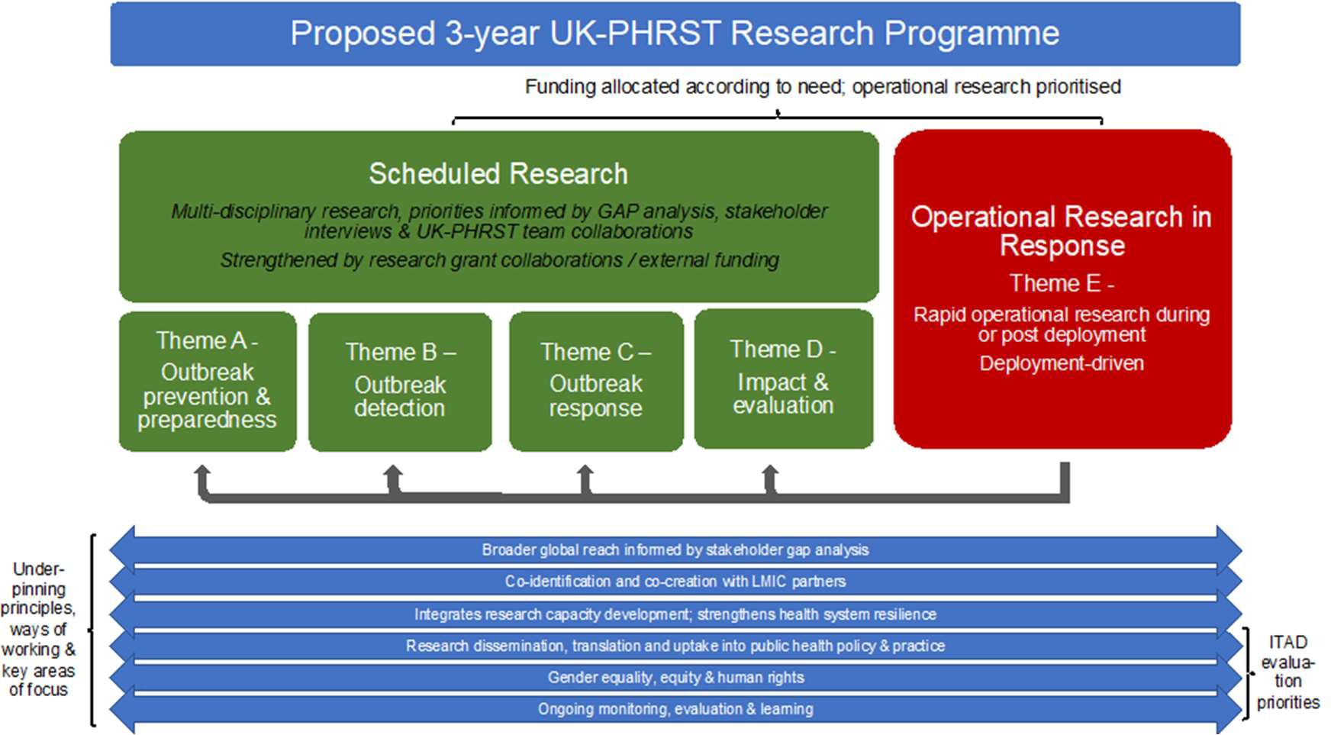

Research gaps – evidence from stakeholder interviews and gap analyses
A previous systematic review identified considerable gaps in the breadth and quality of evidence on health interventions in humanitarian crises.[11] UK-PHRST sought to use a similarly systematic approach for identifying research needs and priorities specifically with respect to outbreak interventions. As part of a cross-remit stakeholder analysis, UK-PHRST commissioned eight interviews with multi-disciplinary external stakeholders to provide relevant context and gain their perspectives on areas to prioritise in outbreak-related research [Appendix 1]. The stakeholders interviewed comprised existing partners and others identified through partner networks, predominantly from LMICs and with good global reach. This work was complemented by a systematic analysis to identify "gaps" where little or no evidence from systematic reviews in outbreak prevention, detection, and response in LMICs is available, using the International Initiative for impact evaluations (3ie) gap map methodology. Together these efforts provided a useful approach for identifying research priorities in LMICs for UK-PHRST.

Capacity gaps for research
Stakeholder interviews highlighted considerable and specific capacity gaps in LMICs that hamper research activities in outbreak preparedness and response, many of which are well recognised development issues whose resolution is beyond the scope and remit of the UK-PHRST. These included funding gaps (and specifically that priorities of researchers and/or LMIC authorities responsible for outbreak prevention and control may differ from those of funders), the absence of a well-structured post-doctoral system to support trained staff retention, inequitable access to high quality scientific information due to journal paywalls, limited data sources for effective surveillance and outcome monitoring, poor laboratory infrastructure (e.g. BSL-3 and BSL-4 labs) and diagnostic capacity (to conduct validation studies, develop rapid diagnostic kits etc.), and inefficient logistics and supply chain mechanisms (including excessive administrative procedures and prolonged turnaround times).

Evidence gaps
The stakeholder interviews also revealed specific gaps in evidence that interviewees considered to be a priority for UK-PHRST funded research. A recurring theme was the need for research to improve outbreak detection systems, including the creation of locally defined case definitions (as opposed to ‘international definitions’). Other priority research areas highlighted were on outbreak prevention (including strengthened genomic surveillance to inform vaccine development and vaccination strategies), improved logistics in outbreak response, one-health, antimicrobial resistance and zoonotic disease, the long-term impacts of outbreaks, and implementation science (including the role of traditional healthcare structures in supporting outbreak preparedness and response policies).

Many of these priority themes chimed with the gaps in synthesised evidence identified in the gap map, most notably around the GHS ToC outcomes in outbreak prevention in terms of vaccination strategies and in outbreak detection including the application of digital technologies and diagnostics. There were further, more specific gaps in synthesised evidence in points of entry, international

- Blanchet K, Ramesh A, Frison S, Warren E, Hossain M, Smith J, Knight A, Post N, Lewis C, Woodward A, Dahab M, Ruby A, Sistenich V, Pantuliano S, Roberts B. Evidence on public health interventions in humanitarian crises. Lancet. 2017 Nov 18;390(10109):2287-2296.

travel, and mass gatherings and also operational support, logistics and supply chains. More generally there were gaps around risk communication, community engagement and infodemic management. There was also a general indication of a need to refocus outbreak research priorities on outbreak prone diseases other than COVID-19, for example on Crimean-Congo haemorrhagic fever, Ebola virus, Middle East respiratory syndrome, severe acute respiratory syndrome, Nipah virus, Rift Valley fever and Zika virus. It is important to note that while the gaps identified reflected areas where limited (if any) systematic review evidence was available, even in areas where systematic reviews were found, evidence was often limited or weak.

Research priorities
Operational research during or immediately in the wake of outbreaks, especially where this has involved a UK-PHRST deployment, will continue to be the highest priority in UK-PHRST’s research portfolio. New situations and research questions will always emerge that cannot be anticipated. The nature, frequency and duration of this type of research is hard to predict. It will be essential to retain UK-PHRST agility and flexibility and build resilience into the scheduled research programme to enable core deployable team members to respond to outbreak response requests and/or to co- develop and co-deliver rapid research projects that addresses these immediate and urgent needs and opportunities.
In terms of the scheduled research programme, the evidence gap analysis including stakeholder interviews identified many areas where research evidence in outbreak preparedness and response could be strengthened and considerably more than could be accomplished with the resources of the UK-PHRST and its partners. While this analysis has had an important influence in prioritising UK- PHRST’s research, team expertise, partner needs and strategic fit with the UK-PHRST remit have been crucial in focusing priorities. For example, while it was an identified need in the gap analysis, research into improving logistics and supply chains is beyond the remit and expertise of UK-PHRST.
As described above, the proposed research portfolio will be classified into themes that reflect the key elements of outbreak preparedness and response plans that underpin effective detection, response and management of outbreaks (Table 2, theme A-D). They align with the GHS ToC outcomes. However, the themes are not rigid structures – we expect research projects and people to work across them. Priorities for research based on these considerations are presented in Table 2.

Table 2. Evidence gaps and priorities by research strategy theme

Strategy Theme | Research priority areas | Example research topics
Prevention & preparedness (A) | - zoonotic disease & one-health  - cross border surveillance  - genomic surveillance  - mental health resilience of health care workers | - assessing hot-spots where risk of pathogen spill over from wildlife to humans is likely so that response measures can be tailored to affected areas  - real-time assays for monitoring early emergence of pathogen variants that allow public health systems to prepare for rapid  spread
Detection (B) | - case definitions & differential diagnosis | - syndromic case definition algorithms for front-line health care workers

 | - early warning systems and timely diagnosis of infectious disease outbreaks  - cross-border collaboration for outbreak detection | - innovative digital technologies & apps as early warning systems to improve detection  - field-based rapid diagnostic tests
Response (C) | - risk communication & community engagement  - infection prevention and control strategies  - vaccine uptake | - designing response measures that are acceptable to communities  - barriers and facilitators for effective vaccine uptake
Impact & evaluation (D) | - implementation science  - action research  - process and impact evaluations of outbreak interventions  - equity in outbreak response strategies | - barriers to uptake of research evidence into relevant policy and/or practice  - evidence of learning application from training/teaching courses

It is important to emphasise that Table 2 presents a guide to priority areas for focussing UK-PHRST research. It is not an exhaustive list of research topics for UK-PHRST and nor is it expected that UK- PHRST research will cover all these areas. Some topic areas are broad, reflecting the findings of the gap analysis and further emphasising the need for exploratory discussions with partners to identify and refine key research questions.
There will be a programme of interrelated and multidisciplinary activities with approximately two long-term larger studies (workstreams) per research theme. Using insight from the gap analysis and stakeholder interviews, the UK-PHRST has begun identifying, with partners, key research questions that fit within the priority research areas, stratified by strategy theme. The aim is that these will produce outputs over the next three years relevant to the needs already identified. Study leads are being encouraged to develop longer-term proposals so that UK-PHRST will have an ambitious and coherent programme of research across the three-year funding cycle.

Strengthening UK-PHRST capacity to deliver research
Historically, delivery of research projects has been somewhat hampered by the conflict between research and deployments. Therefore, over recent years UK-PHRST has expanded team capacity to facilitate ongoing research delivery during busy periods of deployment, through expanded staff recruitment, and greater utilisation of reservists and FETP fellows in deployments and research projects. This approach will continue to be strengthened in the next phase of the programme.
Additionally, with the uplift in funding, UK-PHRST will strengthen key components of its research technical capability to address research priorities, including:
  - creating an implementation science team to evaluate dissemination and uptake of evidence- based practice
  - new resources in molecular epidemiology / genomics, epidemic risk prediction / geographic information systems and digital technologies
  - strengthened resources in social science, mental health and clinical research
The additional capacity will include non-core deployable researchers who can continue to deliver research activities during deployments, thereby strengthening team resilience and sustainability of the research programme.

Strengthening research capacity in ODA-eligible countries and fostering equitable partnerships – recommendations from stakeholder interviews
While addressing some of the capacity gaps identified during the stakeholder interviews goes beyond the remit and technical expertise of the UK-PHRST, there are areas where UK-PHRST could enhance its offer, including:
  - supporting capacity building projects that develop frameworks and/or toolkits supporting sustainable surveillance systems, laboratory capabilities and supply chain logistics
  - providing teaching and training to junior researchers in LMICs in surveillance methodologies and diagnostics
  - supporting fellowships for in-country post-doctoral researchers
  - sharing standard operating procedures and/or best practice that support the delivery and management of research in LMICs
Additionally, stakeholders suggested ways that UK-PHRST can support research capacity development in LMICs through strengthened and more equitable research partnerships. Stakeholder interviews highlighted the need for genuine equity in research partnerships, including greater transparency in partnership arrangements and project leadership by LMIC partners. UK-PHRST will re-focus its efforts towards fostering genuine co-identification and co-creation of research proposals thereby ensuring UK-PHRST funds research that meets the needs identified by LMIC partners and supports them to deliver it. To help achieve this, all new research proposals will be rigorously assessed to ensure that LMIC partners identified or co-identified the research need or, at minimum, co-created the research question and methodology. To build LMIC partners’ capacity to deliver research and support their professional development in academia, UK-PHRST will also ensure that, wherever possible, all research is led or co-led by LMIC partners and that LMIC partners are first or senior authors (and preferably both) on peer-review academic publications.
As recommended by stakeholders, UK-PHRST will continue to work closely with LMIC institutions that are demonstrating research leadership by defining and prioritising strategic research objectives, such as Africa CDC¹² and Nigeria CDC.¹³ We also aim to expand collaborations with similar regional and national public health institutes in other global regions, including those that are less well recognised, to help strengthen research capacity and leadership. Furthermore, as well as working with Ministries of Health, it will broaden and deepen partnerships with relevant LMIC universities at the vanguard of outbreak preparedness and response research given their in-depth, country-specific understanding of the research landscape and systems. In addition to continuing longstanding partnerships, the UK-PHRST is identifying new academic partners in LMICs through a combination of recommendations from stakeholder interviews and existing partners (snowballing approach) and pre-existing professional relationships. They are being selected based on their expertise and its relevance to our research, capacity development priorities and remit. Through this process we have been proactively seeking to increase partner representation from South East Asia and Central and South America.
Stakeholder interviewees also emphasised the value of and need for greater south-south collaborations in outbreak preparedness and response research to enable exchange of mutually relevant resources, technology and knowledge between LMICs. UK-PHRST will therefore identify opportunities for, and encourage and collaborate on, more ‘south-south’ collaborations within and

12 https://africacdc.org/programme/national-public-health-institutes-and-research/
13 https://ncdc.gov.ng/themes/common/files/establishment/fdaa94605dcb87478f9b12002ff7eeb7.pdf

across global regions. One partnership that will strengthen such a collaboration is the University of Brasilia in Brazil. This is a new LMIC partner that was identified through an existing professional network. The university was approached because it is the leading academic institute in South America for developing novel and innovative approaches for rapid outbreak detection including digital tool development (a priority in research theme B), has strong research collaborations with Portuguese speaking African countries and has a long-standing track record in international field epidemiology training programmes. Discussions with other potential partners are underway. UK- PHRST will also facilitate research with greater cross-border collaboration that can improve outbreak detection and surveillance systems, especially in remote border areas.
UK-PHRST has also developed strong academic links with multiple UK partners. We anticipate these will continue while we also broaden our UK academic partnerships. We will continue the formal collaboration with Oxford University through the Pandemic Sciences Centre. Oxford University will continue to provide and lead a significant portfolio of clinical research and will develop new research in One Health and implementation science. We will also continue to work with the Liverpool School of Tropical Medicine on the development of rapid diagnostics. We have also formed formal partnerships with LSHTM centres of particular strategic importance: The Health in Humanitarian Crises Centre, the Centre for Evaluation, and the newly formed Centre for Epidemic Preparedness and Response. All UK (or other potential high-income country)-based partners will follow the same principles of genuine co-identification of research needs and co-creation of proposals with LMIC partners.
UK-PHRST will continue to explore and expand opportunities to support development of research capacity through academic and practical teaching and training aligned to its mandate.

CAPACITY DEVELOPMENT

Background and rationale
Less than one-third of WHO Member States have implemented the IHR core capacities, the vast majority of those that have not are LMICs. Furthermore, the 2021 Global Health Security Index found that despite significant steps taken by countries to respond to the COVID-19 pandemic, all countries remain dangerously unprepared to meet future epidemic and pandemic threats, with an average country score of 38.9 out of 100¹⁴.

Building capability overseas is a vital component of strengthening GHS and strengthening LMICs’ capacity to prepare, prevent and respond to disease outbreaks. The capacity development component of UK-PHRST’s triple mandate model is essential to contribute towards sustainability and UK-PHRST’s contribution to intermediate and longer-term outcomes for outbreak preparedness and response.

The UK-PHRST has demonstrated success in delivering capacity development projects over the past six years to support and improve outbreak preparedness and response. UK-PHRST has delivered projects in training and education for outbreak response that have successfully developed capacity, and has worked with global, regional, and country level partners to support development of policies, protocols, and training in outbreak preparedness and response. For example, early in the COVID-19 pandemic, UK-PHRST trained Nigeria CDC microbiologists to develop their capacity to conduct whole

14 Jessica A. Bell and Jennifer B. Nuzzo, Global Health Security Index: Advancing Collective Action and Accountability Amid Global Crisis, 2021.

genome sequencing during a project on Monkeypox. Subsequently Nigeria CDC produced its first SARS-CoV-2 genome and it continues to provide this service independently. UK-PHRST has also delivered educational support and supported digital learning through (i) a Masters in Public Health and BSc in Medical Laboratory Science in Sierra Leone, (ii) an online course on “Pandemics: Emergence, Spread and Response”, and (iii) the first Massive Open Online Course on tackling COVID- 19, which was completed by over 236,000 participants from 184 countries worldwide, 123,516 of whom were from LMICs.

Capacity development gaps
An external review of the UK-PHRST by ITAD (2021) made several important recommendations to strengthen UK-PHRST’s capacity development work, which was seen by many stakeholders to be the most strategic and relevant aspect of the triple mandate towards sustainable outcomes. The following opportunities were identified:

- further refining, clarifying, and increasing awareness of UK-PHRST’s approach to capacity development for any future phase
- better defining the UK-PHRST capacity development ‘offer’ and build on existing and new partnerships with other actors to complement this offer, with a view to improving sustainability of outcomes
- better defining and reinforcing clear mechanisms for accountability to facilitate and enhance strategic leadership and effective implementation of the capacity development component of the triple mandate

Consequently, the UK-PHRST developed a document outlining the UK-PHRSTs approach to capacity development (April 2021), conducted a rapid internal review of capacity development, and a rapid workforce evaluation (January 2022) to better define UK-PHRST capacity development activities and provide recommendations to strengthen implementation.

Capacity development definition and scope
The UK-PHRST defines capacity development as activity which increases the ability of individuals, organisations, and societies to deliver specific tasks and mandates¹⁵. It builds on existing skills and knowledge, driving a dynamic and flexible process of change, borne by local actors¹⁶, it is an internal process, for which external actors play a supporting role.

Although UK-PHRST deployments and research projects will build experience in multiple countries and create valuable contacts for future collaboration, long-term capacity development cannot be effectively achieved by these short-term engagements alone. It is imperative to complement short- term capacity development engagement with stand-alone capacity development projects, enabling ongoing exchange and growth in skills and capacities. The UK-PHRST capacity development scope has two main components comprising:
- integrated capacity development activities which are embedded within all UK-PHRST deployments and research project across LHSTM and UKHSA. We adopt approaches and conduct activities during deployments that contribute to real-time capacity development, and we embed capacity development activities and approaches within our research projects
- specialised capacity development projects which are stand-alone capacity development projects. These emerge from response and research activities and learning and are designed to improve

15 UNDP, Capacity Development: A UNDP Primer. 2015.
16 EPRS, Understanding capacity-building/capacity development. A core concept of development policy. European Parliament. 2017.

outbreak preparedness and future response capacity, strengthen UK-PHRST partnerships, and contribute to strengthening local capabilities to meet IHR

Conceptual framework
Capacity development is an iterative and complex process with different domains and interpretations. The UK-PHRST have developed a capacity development conceptual framework to serve as a visual representation of different capacity development constructs, variables, and dimensions (Figure 7). The purpose of which is to provide a common reference point embedded across UK-PHRST, to improve the design of capacity development projects, broadening capacity development approaches to enhance effectiveness, and to communicate the UK-PHRST capacity development workstream to key stakeholders.

Successful capacity development requires enhancing the capacities of individuals whose ability and performance greatly depend on the capacities and performance of the organisations within which they work, both of which are influenced by the broader enabling environment. In addition, effective capacity development requires support to target multiple capacity domains relevant for performance. The focus of the UK-PHRST capacity development workstream is to support and improve internal and external capacity for epidemic detection, prevention, and response. This is achieved through the delivery of capacity development activities across multiple interlinked levels, targeting technical, functional, and operational capacity domains.

Figure 7: UK-PHRST Capacity Development Conceptual Framework
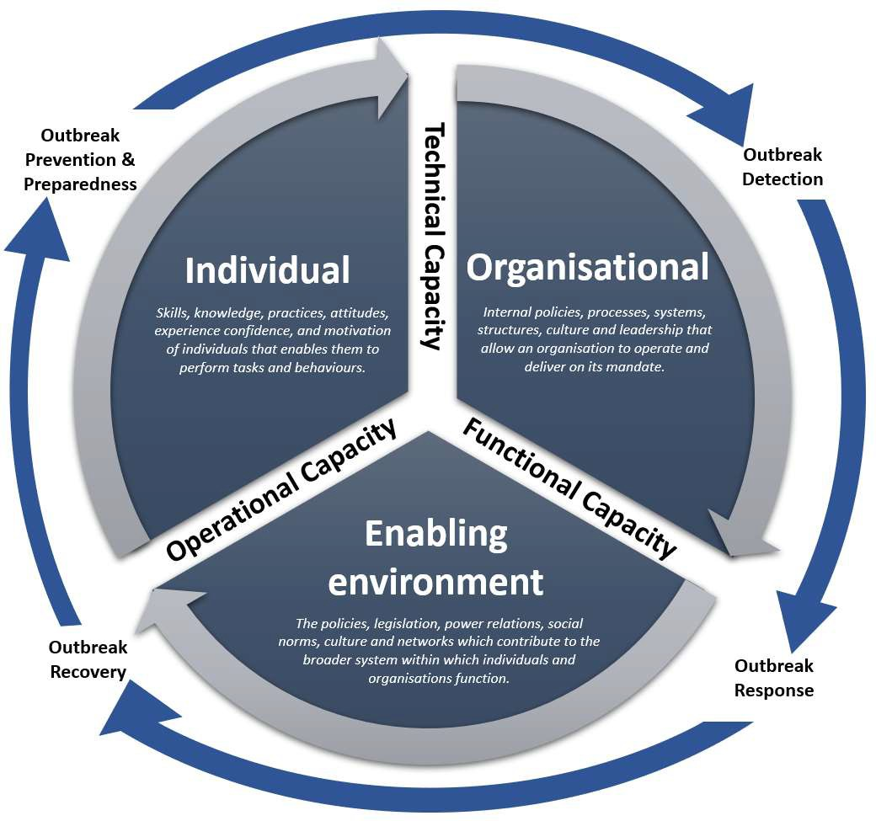

Capacity development offer
The UK-PHRST capacity development workstream is delivered across the triple mandate via integrated capacity development activities and specialised capacity development projects. The UK-PHRST capacity development offer (Figure 8) supports capacity development at local, national, regional, and global levels, working with national ministries of health, national and regional public health institutes,

and academic institutions in LMICs. The UK-PHRST works with partners to co-design and collaboratively deliver capacity development projects. Capacity development activities are delivered both formally and in-formally, reactively during responses, and proactively outside of responses. Activities and projects are tailored to partner needs and priorities, and adaptative to context, to support strengthening epidemic prevention, detection, and response. A prioritisation tool has been developed after consultation with stakeholders and will be used to inform on which areas of capacity development the UK-PHRST will devote resources.

Figure 8: UK-PHRST Capacity Development Strategic framework
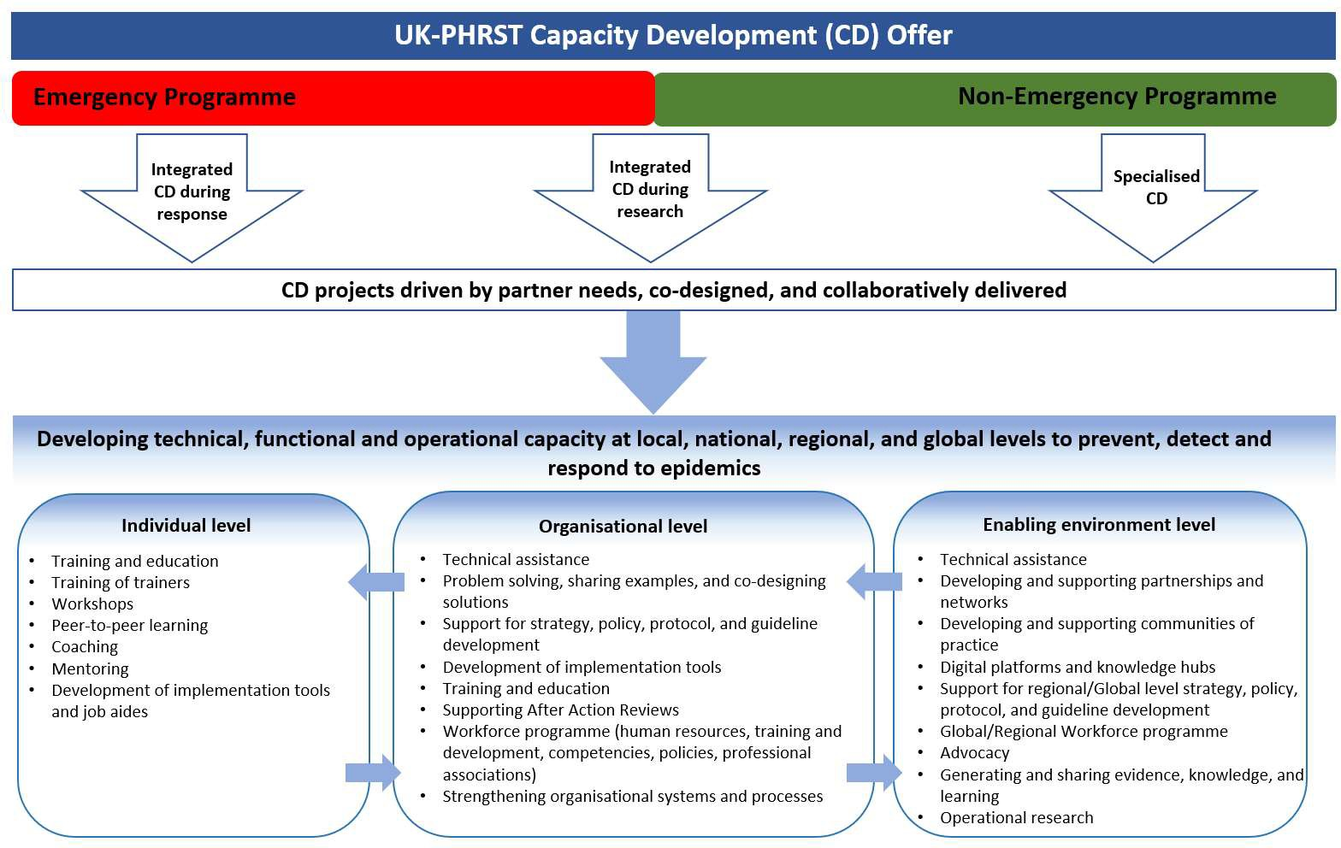

UK-PHRST capacity development 2022-2025
The UK-PHRST is adapting its structure to improve the governance, accountability, and quality of capacity development activities and projects. A new capacity development, training, and learning pillar will be established to lead and coordinate capacity development activities across UK-PHRST. This new pillar will be responsible for developing, delivering, and managing the strategic direction of capacity development activities within the UK and in LMICs, with support from relevant technical expertise across UK-PHRST, as well as ensuring long-term sustainability of activities. The emergency capacity development will continue during and after deployment with the added aid of having a clear set of criteria to assess the priority of these actions and informed by the workforce development evaluation when completed. As well as providing support across UK-PHRST in the design and implementation of capacity development projects, the global public health consultant will act as the focal point, working with the capacity development planning team to ensure proposed capacity development projects are aligned with UK-PHRST programme priorities and outcomes.

Capacity development priorities 2022-2025
The UK-PHRST has outlined 6 development priorities which include:
- integrating learning from 5 years’ experience to optimise capacity development directed at global, regional, and local levels to develop effective global outbreak capacity
- engaging with external stakeholders to co-develop the UK-PHRST capacity development agenda, clearly outlining strategic priorities for UK-PHRST capacity development projects over the next 3 years
- engendering a culture of quality improvement by embedding monitoring, evaluation and learning across capacity development activities and projects
- expanding UK-PHRST partnerships to deliver capacity development projects, promoting equitable partnerships through co-creation and co-leadership with LMIC institutions for mutual learning and benefit, to enhance the impact and sustainability of UK-PHRST capacity development projects
- strengthening collaboration and coordination with stakeholders delivering long-term capacity development activities for epidemic prevention, detection, and response to enhance the sustainability of UK-PHRST’s capacity development support
- Improving governance and implementation through the Capacity, training and educational pillar to ensure prioritisation of projects is gated to justify action in consideration of LMIC partner need, public health need, sustainability, impact and UK-PHRST capacity and capability

Training and education
UK-PHRST will continue to explore and expand opportunities to support development of research and technical capacities through academic and practical training and education in line with UK- PHRST mandate.
UK-PHRST training and education function will operate in accordance with best practice, will maximise in-house learning capability, support innovative and cost-effective approaches to learning and development, and will contribute to continuous improvement in performance for both team members and partners in LMICs.
The training and education activities will be guided by the Analyse, Design, Develop, Implement, and Evaluate and Experiential Learning theory (Kolb, 2014¹⁷) (ADDIE) as a framework in designing and developing educational and training programs. Learning and development needs will be identified through the twin approach of formal training needs assessment and the performance management and development systems.
Strategies are the mechanisms that are chosen to help increase human resource capability and improve performance to support the achievement of objectives. Recognising that learning and development is multi-faceted, our approach will be through a combination of the methodologies including on the job learning, self-managed learning, group learning and tutor led learning. Subject matter experts will be supported to develop training and facilitator skills, where needed, through
e.g. training in pedagogy and learning methodologies; consultancy provision; and creating and sharing a repository of tools, guidelines and information on best practices in development, delivery and evaluation of learning activities. This approach will help to optimise use of existing resources to support training and, also support professional development of subject matter experts.

¹⁷ Kolb, D. A. (2014). Experiential learning : experience as the source of learning and development.

Training and education development priorities 2022-2025:

The UK-PHRST has outlined 7 education development priorities which include:

- updating priorities and plans for training and education at the individual and organisational level
- co-designing tailored training with partners and develop credit-bearing online courses.
- sharing reflections, learning and resources from response activities through the Knowledge Sharing Hub
- identifying or create opportunities to strengthen internal learning through discussion, reflection and learning about our work
- enhancing and deepen collaboration between team members through discussion, reflection and learning about our work, including areas of synergy and overlap and how we can better support one another
- creating opportunities to enhance knowledge sharing/exchange formally with partners
- providing a mechanism to produce and share valuable (formal and informal) structured, learning products within the team and with our partners

A core commitment of the UK-PHRST is to seek greater levels of social equity in the delivery of its mandate. Within the learning component of our work we will accomplish this in four ways:
- ensuring that partner-targeted training is advertised to as wide an audience as possible, especially ensuring that there is equity in the representation of men and women
- ensuring that we increasingly have LMIC partner facilitators and trainers wherever possible
- in the evaluation we seek out the views of a diverse set of voices participating in the training
- internal reflection and learning sessions are inclusive of the range of views and voices represented in our team composition.

GOVERNANCE, GUIDANCE AND MANAGEMENT

Governance arrangements were developed and put in place to oversee effective initiation of this UK- PHRST. The governance structure will now be strengthened and will reflect the joint nature of the partnership (Figure 9).

Global Health Security Programme Board
The GHS Programme Board is chaired by the DHSC International Director, the Programme’s Senior Responsible Owner (SRO). Members represent the Programme’s key partners (including UKHSA and FCDO) and provide support to the Chair and SRO on progress and delivery. The GHS Programme Board holds the Director of the UK-PHRST to account for delivery of the UK-PHRST project. These arrangements complement and respect the internal accountability arrangements in both UKHSA and LSHTM. The Global Health Oversight Group provides an additional opportunity for cross-government partners to consider and lead the strategy for global health across government. The Deputy Chief Medical Officer also provides senior strategic direction.

Figure 9. Governance, reporting and feedback structure for the UK-PHRST.
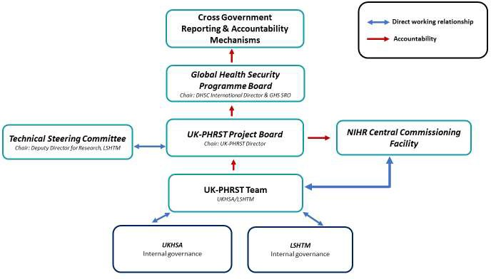

The UK-PHRST is a partnership between UKHSA and the LSHTM. The UK-PHRST Director who, like all UK-PHRST members, has joint appointments at UKHSA and LSHTM is accountable for internal governance and direction. The Director is accountable to the DHSC GHS Programme Board.
Reporting, feedback and guidance is provided and received by a broad number of partners and stakeholders in UKHSA, HMG and LSHTM.
Existing management and governance arrangements will be maintained, including:

UK-PHRST Project Board

A UK-PHRST Project Board (PB) has been established and holds quarterly meetings to assist the UK- PHRST in the following ways:
- providing expert technical advice and challenge
- contributing to strategic and operational discussions
- assisting the UK-PHRST in addressing any management or operational obstacles that may arise
- reviewing budget expenditures and forecasts
- reviewing progress against deliverables in the logframe indicators
- ensuring that appropriate links and alignment are made with other key elements of the HMG GHS agenda and that interdependencies with other planning processes are managed effectively
- reviewing the risk register on a regular basis, and assist with resolving strategic level risks and issues as raised by the UK-PHRST Director and SRO of DHSC’s GHS Programme
- serving as liaisons to their respective boards and organisations to ensure that they are appropriately informed on UK-PHRST progress
The role of the PB is to advise and provide recommendations on the development and implementation of the Strategic Framework that reflect the vision and meet UK-PHRST objectives. Decision power on PB recommendations rests with the UK-PHRST Director, who is accountable to the DHSC GHS Programme Board.

Board composition
The PB will be chaired by the UK-PHRST Director. Board members will be from across HMG (e.g. DHSC, UKHSA, NIHR, FCDO), academia (e.g. LSHTM, University of Oxford), and other stakeholders (e.g. WHO, MSF) and will hold two-year terms, renewable upon mutual agreement. Members will be selected based on their experience and expertise in the three key components of the UK-PHRST: Outbreak response, outbreak and infectious disease-related research, and capacity building/training for outbreak prevention, preparedness, and response. At least one PB member will also be a member of the UK-PHRST TSC to ensure communication and congruity between these two bodies.

Technical Steering Committee
The Technical Steering Committee (TSC) was established to provide independent advice and support to the UK-PHRST regarding its research portfolio. The TSC will continue to review new research study proposals to ensure they are to the expected scientific and academic standard and are in alignment with the objectives and priorities of UK-PHRST’s research strategy. To further strengthen its role, TSC membership and meeting attendance will be regularly reviewed to ensure that members fully cover the scientific fields and expertise relevant to UK-PHRST triple remit, adequately represent LMICs, and miss no more then two consecutive meetings. As LMIC representation has been relatively weak, UK-PHRST is committed to broadening LMIC representation on the TSC.
The TSC is also complemented by the Academic Advisory Group (AAG) that will continue to provide senior academic input into the UK-PHRST’s research strategy and ensure continued engagement of senior leadership at LSHTM with the UK-PHRST and alignment of the programme with LSHTM’s strategic goals.

UK-PHRST Senior Management Team (SMT)
Day-to-day governance is managed by the UK-PHRST SMT, comprising a group of senior staff representing key work streams and the UK-PHRST Director. The SMT meets fortnightly to monitor progress, discuss challenges, agree actions, review the financial position, and manage risks to the programme.

Ethics Committees
Assurance on ethics is delivered for all UK-PHRST research projects through approval via the ethics committees at UKHSA, LSHTM, and other academic partners as appropriate.

Project management
The following structures will be used to ensure strong project and risk management:
- rigorous deployment processes and procedures – these have been reviewed and strengthened since the initiation of the programme and are in place to support all deployment travel. All deployments and travel involving logistics support are assessed through a semi-structured post- deployment debriefing session, with the aim of identifying areas to strengthen and inform future practice. End of mission reports summarise each deployment and are circulated to HMG

partners. An annual after action review inviting external stakeholders takes place to assess and critically evaluate processes and gaps
- lessons log – the UK-PHRST is committed to continual learning and reflection to ensure that processes are always strengthened as a result of capturing and acting on lessons systematically.
- robust research management processes – these are well established, and include research proposal scrutiny by the TSC, careful planning of research project budgets and resourcing, regular monitoring of progress against milestones, and end of project meetings with the Research Management Group to identify lessons learnt and potential next steps, and project evaluation
- robust capacity development project processes - these will include proposal scrutiny by the capacity development review group in UK-PHRST, planning of project budgets and resourcing, monitoring of progress against milestones, and project evaluation
- audits – regular internal audits of systems and practices will take place, with lessons identified leading to appropriate updates to internal processes. This includes auditing a range of project management activities including finance, logistics and travel. The UK-PHRST management will actively support any requests from the Government Internal Audit Agency
- monitoring and evaluation – a new monitoring and evaluation framework is now in place with strengthened processes to communicate log frame indicator progress on a quarterly basis

REPORTING REQUIREMENTS

This strategic framework will be assessed periodically with evaluations commissioned by the UK- PHRST Director, GHS Programme Board, and/or NIHR CCF. Key elements of ongoing monitoring, review of progress and summary of achievements include:
- quarterly Highlight Reports to the DHSC GHS Programme Board and the NIHR CCF. This report will include a high-level overview of progress, finances, risks, and their mitigation
- annual review report to DHSC and NIHR CCF, which will include performance against logframe indicators
- situation reports (SitReps) to DHSC SRO on a weekly basis during operational deployments to provide HMG stakeholders (including NIHR) with updates on the response to an emergency situation as it evolves over time
- end of mission reports to HM government stakeholders to provide an assessment of the implementation of the mission's mandate and lessons identified for the UK-PHRST and wider HM government
- research projects progress reports to NIHR and the TSC annually
- financial report (LSHTM contract) to be provided both annually and on a quarterly basis (Oct, Jan, April, July) to NIHR CCF
Many of the above communications will be routinely further disseminated by DHSC to stakeholders across HM government.

RISK MANAGEMENT
The UK-PHRST has instituted a thorough and systematic risk management structure. This process ensures that the risks associated with the UK-PHRST are systematically and formally identified, assessed, and mitigated within acceptable levels.
Two distinct areas of risk are considered:
  - strategic risk – risks to the effective delivery of the UK-PHRST
  - operational risk – risks relating to specific deployments

Strategic risk
The UK-PHRST risk register will continue to be reviewed and updated on a quarterly basis. The register considers risks of the programme meeting its objectives to time and budget and considers a wide range of reasons for and impacts of each risk. The UK-PHRST Project Board, GHS Programme Board and NIHR are kept informed about key risks routinely. Anything requiring escalation is done so through agreed channels in a timely way. UK-PHRST representatives feed into risk management processes at both organisations.

Operational risk
The UK-PHRST has an operational risk register in place which is reviewed and updated quarterly. The UK-PHRST is represented on the UKHSA Health Protection and Medical Directorate Risk Leads group. Once a deployment has been approved and accepted, a comprehensive health, safety and security orientated risk assessment is carried out. This risk assessment is country and outbreak specific and focuses on protecting the health and wellbeing of deployed UK-PHRST staff members. The assessment is produced using UKHSA Safety Organiser software and covers a range of common hazards relating to travel, accommodation, health in the field, personal safety and communication. Most mitigating measures have been considered, adopted in advance and communicated to the deploying individuals as part of their induction, training and briefing processes. Other bespoke measures are also agreed as part of the risk assessment process. The risk assessment is approved and signed off by the UK-PHRST Director. An e-learning module on risk assessments is in development for use by UK-PHRST staff.

MONITORING AND EVALUATION

Embedding monitoring, evaluation & learning

Monitoring
A MEL plan has been developed to guide the implementation of a refreshed UK-PHRST adaptive logframe. The logframe contains the proposed results (at the impact, outcome and output levels), a set of associated SMART indicators, agreed targets and data sources. UK-PHRST adopts an adaptive approach to the implementation and monitoring of its logframe. This means that learning generated from our data will be regularly reviewed to assess the continuing relevance and appropriateness of both the indicators and the results we seek to achieve. Data will be generated from diverse data sets including surveys, feedback forms, research reports, training reports, case studies and meeting minutes. The logframe will be reviewed and refreshed annually as required. Quarterly reports will be

produces to support monitoring meetings which will be held quarterly at the project and programme board level.
Data is collected by monitoring officers. Each monitoring officer is assigned a result at the impact, outcome or output level, for which they compile and publish the data in a central database.
Generated data originates from both sides of the partnership – UK-PHRST and the partner country/organisation. Both arms of the partnership sign off on the data before it is submitted. In addition, a partner survey is held at least twice a year. Partner feedback provides a partner perspective on the data and also serves to verify its authenticity.
All data generated form the basis for UK-PHRST’s learning. External and internal learning sessions will be scheduled to discuss and reflect on learning from data generated and the implications for the development of the project.
Learning data will enable a robust and applied evidence base to help embed in the work of RST.

Evaluation
Plans for an external UK-PHRST evaluation of the programme during the new three-year funding cycle are currently under review. The UK-PHRST recognises that elements of process evaluation (how well programme activities have been undertaken to understand factors that enable or hamper its implementation), thematic evaluation (of specific themes of practice and their quality), outcome evaluation (where we assess how well medium-term results have been achieved, including those intended and unintended both positive and negative outcomes) and impact evaluation (where we determine how well our goals have been achieved, including intended and unintended both positive and negative impacts) can and should be addressed as part of an integrated monitoring, evaluation and learning approach. This will generate the range of evidence and learning needed to inform decisions about the impacts, outcomes and outputs over the lifespan of UK-PHRST activities and projects, contributing to a more comprehensive evaluation exercise. We have designed UK-PHRST’s MEL system with this in mind.
Subject to resource availability, routine monitoring feedback and learning on UK-PHRST’s performance will help highlight areas of the project’s quality and performance that require improvement. Our learning reviews will enable us to pose evaluative questions along these lines. Additionally, implementation science – research into the uptake of evidence into policy and practice (its impact) - will form a central plank of UK-PHRST’s research strategy.
Any scheduled external evaluation would take place close to the end of the project cycle and would be managed internally by UK-PHRST’s MEL lead and project team. UK-PHRST’s MEL lead will also oversee mini-evaluations tracking UK-PHRST’s ongoing progress in selected areas. We will also record evidence of value for money (VfM) on a quarterly basis. The Itad review highlighted that despite considerable progress made in strengthening UK-PHRST’s MEL systems, further effort is needed to deliver and demonstrate delivery of the desired outcomes. This finding is particularly relevant for research, and the newly appointed MEL lead at UK-PHRST will introduce enhanced mechanisms to embed a MEL approach across our research.

EQUITY AND HUMAN RIGHTS

Embedding Equity & Human Rights
UK-PHRST is taking steps to upskill our understanding of and ability to embed equity and human rights (EHR) as a priority across the triple remit. We commit to discussion and collective reflection to establish our EHR values as a team, and to determine key indicators within this area across UK- PHRST work and behaviours. Through this we aim to identify and implement practical steps that challenge us to recognise, consider and address human rights and social equity issues that arise throughout our work. With our in-country partners, we aim to collaboratively determine what makes for equitable partnerships and how we can work continuously to build and achieve them together.
Staff will be trained and supported to recognise and consider at-risk groups, the compounding impact of overlapping social identities and the health inequalities experienced and commonly exacerbated during an infectious disease spread. Implementing appropriate categories of data disaggregation (e.g. gender, age etc.) is key to this work.
EHR will also be embedded into the type and delivery of research that UK-PHRST does. To achieve this, UK-PHRST will develop guidance outlining the under-pinning principles and recommended approaches for strengthening EHR in research.
To ensure that EHR principles underpin research projects from the outset, research proposal templates will be adapted to include a researcher assessment of how the project recognises, considers and addresses EHR, EHR objectives and/or milestones that can be reviewed regularly and plans for evaluating the impact of the project on EHR. Additionally, UK-PHRST will encourage and promote the development of new research questions that specifically address EHR in the context of outbreak preparedness and response, for example, around the impact of responses on gender equity. UK-PHRST is building on its partnership with the Health in Humanitarian Crises Centre at LSHTM which will further strengthen partnerships across LSHTM and cooperation on EHR.
We are working to establish effective ways of measuring and capturing the progress and impact of our work in implementing EHR across the triple remit.

FINANCIAL MANAGEMENT AND ACCOUNTING

The UK-PHRST is funded from the ODA budget. Consequently, in line with the Organisation for Economic Co-operation and Development rules, all spending must further the sustainable development and welfare of LMICs and be likely to contribute to a reduction in poverty.

Monitoring, reporting, and accounting of expenditures

The UK-PHRST will review expenditure on a quarterly basis and provide regular financial reports to the DHSC core team and NIHR, indicating actual spend, any re-profiling of spend and the planned spend for the following period. This will be a formal reporting mechanism by which to ensure UK- PHRST is on track towards the annual financial targets and ODA reporting requirements, including the requirement to budget expenditure within calendar year periods.
Actual costs are incurred in UK-PHRST by both UKHSA and LSHTM and each is responsible for ensuring that all recorded expenditure is eligible to be claimed under the rules of ODA funding.

Actuals are monitored on a regular basis, with transactions being reviewed each month for completeness and accuracy. Where items have been incorrectly allocated, they will be moved with the support of the relevant finance department.
The UK-PHRST Director and Senior Programme Manager will take an overview of the financial position across both partners. They will be responsible for ensuring that a combined finance report covering all items of expenditure is completed on a quarterly basis and submitted to the Management Team for their information and action where appropriate.
The UK-PHRST Senior Management Team meets every two weeks to discuss activities and review finances, including allocation of the non-staffing budgets between different activities. This process enables joint reporting of financial information across the entire UK-PHRST, with the Senior Programme Manager, based at UKHSA, acting as the person with overall responsibility to report all financial activity. Approaches to underspends, with reallocation of unused funds to other UK-PHRST priorities, are being developed to maintain the VfM of the operation. These will, of course, take into account existing contractual relationships with the various academic partners.
The financial position is reported externally to NIHR and DHSC regularly; with forecast and actual spend figures provided on a quarterly basis. Forecasts will be updated each month by the Programme Manager, and significant under or overspends will be discussed with the Director, to ensure that any surplus funds be spent on other PHRST priorities within the financial period required to be claimed under ODA rules. The partners have agreed a protocol for transferring funds between themselves should it ever be necessary to redistribute funding to ensure that all available money is spent on appropriate ODA-eligible items.

Framework for priority setting and resource allocation
It is important that the UK-PHRST prioritise spending to achieve objectives and ensure efficient resource allocation, thereby maximising impact and VfM. Given the unknown number of outbreaks and deployments in any given year, we need to have a system to balance the costs of deployments and research throughout the four-year period and an expectation of needing to transfer funds between the allocated budgets for UKHSA (the primary implementer for outbreak response) and LSHTM (the primary implementer for research). This flexibility will require:
- effective horizon scanning to inform potential requests
- systematic prioritisation of areas of activity
- effective allocation of resources
- procedures and criteria for realignment
- timely repurposing of unused/unspent budget
- ensuring that VfM is achieved

LOGICAL AND RESULTS FRAMEWORK

An Annual logframe applying iterative learning will be agreed with DHSC in Q1 of each year 2022- 2025.
A detailed logical framework for 2022-23 is presented in Appendix 3.

STAKEHOLDER ENGAGEMENT AND COMMUNICATIONS

A fixed-term contract senior communications manager joined the UK-PHRST in April 2022. This manager is the communications lead for the UK-PHRST and will work in collaboration across the team, UKHSA, LSHTM, government departments and relevant partner organisations to develop and deliver a proactive stakeholder engagement and communications strategy, as well as a tactical communications plan.

PAGE \* MERGEFOR

